| Cybersecurity |
| --- |
| Project 3 Review Questions |

## Windows Server Log Questions

**Report Analysis for Severity**

* Did you detect any suspicious changes in severity?

| Yes, the “high” severity count increased from 329 to 1111, a huge increase.  (Find graph at end of page) |
| --- |

**Report Analysis for Failed Activities**

* Did you detect any suspicious changes in failed activities?

| Interestingly, the number of failures has decreased from our baseline to when under attack.  (Find graph at end of page) |
| --- |

**Alert Analysis for Failed Windows Activity**

* Did you detect a suspicious volume of failed activity?

| Yes, a suspicious volume of failed activity was evident.  (Find graph at end of page) |
| --- |

* If so, what was the count of events in the hour(s) it occurred?

| We noticed 35 failed events in a single hour, much higher than our previous baseline that had a maximum of 10 failed events an hour. |
| --- |

* When did it occur?

| The 35 failed events happened at 8:00AM on March 25, 2020. |
| --- |

* Would your alert be triggered for this activity?

| Our alert was set to be triggered if the count of failed events exceeded 12 failed events per hour (double our baseline failed event count), so yes, our alert would be triggered. |
| --- |

* After reviewing, would you change your threshold from what you previously selected?

| Knowing that during an actual attack, the volume will be much higher than our baseline, we would probably choose to raise our threshold a bit, such as to 15, just to avoid getting false positives if one day happened to have a slightly higher count of failed events, versus an actual attack with a higher volume of failed events. |
| --- |

**Alert Analysis for Successful Logins**

* Did you detect a suspicious volume of successful logins?

| Yes, we detected a suspicious volume of successful logins.  (Find graph at end of page) |
| --- |

* If so, what was the count of events in the hour(s) it occurred?

| There were 11 successful logins. |
| --- |

* Who is the primary user logging in?

| Primary user logging in was user_a |
| --- |

* When did it occur?

| It occurred at 2:00AM on March 25, 2020. |
| --- |

* Would your alert be triggered for this activity?

| Yes, our threshold was set to 8 successful logins per hour per user, so the 11 successful logins definitely would have triggered our alert. |
| --- |

* After reviewing, would you change your threshold from what you previously selected?

| No, in this case, I think our threshold was appropriate and it did successfully detect the intrusion. If we were going to improve the alert, rather than simply changing the threshold, it seems like it would be more useful to alert on “off hours” login attempts. |
| --- |

**Alert Analysis for Deleted Accounts**

* Did you detect a suspicious volume of deleted accounts?

| Yes, there was a suspicious volume of deleted accounts.  (Find graph at end of page) |
| --- |

**Dashboard Analysis for Time Chart of Signatures**

* Does anything stand out as suspicious?

| From 12:00-3:00 AM on Wed March 25 2020 the signature “a user account was locked out” had suspicious activity. Also from 8:00-11:00 AM on Wed March 25 2025 the signature “ an attempt was made to reset an accounts password” had suspicious activity.  (Find graph at end of page) |
| --- |

* What signatures stand out?

| A user account was locked out and an attempt was made to reset an account's password. |
| --- |

* What time did it begin and stop for each signature?

| “A user account was locked out” begin at 12:00 AM stopped at 3:00 AM  “An attempt was made to reset an accounts password” begin at 8:00 AM stopped at 11:00 AM |
| --- |

* What is the peak count of the different signatures?

| “A user account was locked out” peak count was 896  “An attempt was made to reset an accounts password” peak count was 1258 |
| --- |

**Dashboard Analysis for Users**

* Does anything stand out as suspicious?

| There was suspicious activity from user_a at 12:00-3:00 AM on Wed Mar 25 2020 and user_k from 8:00-11:00 AM.  (Find graph at end of page) |
| --- |

* Which users stand out?

| User_a and User_k stand out due to suspicious activity. |
| --- |

* What time did it begin and stop for each user?

| User_a activity begin at 12:00 AM and stopped at 3:00 AM on Wed Mar 25 2020  User_k activity begin at 8:00 AM and stopped at 11:00 AM on Wed Mar 25 2020 |
| --- |

* What is the peak count of the different users?

| User_a peak count is 984  User_k peak count is 1256 |
| --- |

**Dashboard Analysis for Signatures with Bar, Graph, and Pie Charts**

* Does anything stand out as suspicious?

| From 12:00-3:00 AM on Wed March 25 2020 the signature “a user account was locked out” had suspicious activity. Also from 8:00-11:00 AM on Wed March 25 2025 the signature “ an attempt was made to reset an accounts password” had suspicious activity.  (Find graph at end of page) |
| --- |

* Do the results match your findings in your time chart for signatures?

| The data match for “a user account was locked out” and “an attempt was made to reset an account password” data match up with other information gathered from the dashboard. |
| --- |

**Dashboard Analysis for Users with Bar, Graph, and Pie Charts**

* Does anything stand out as suspicious?

| There was suspicious activity from user_a at 12:00-3:00 AM on Wed Mar 25 2020 and user_k from 8:00-11:00 AM.  (Find graphs at end of page) |
| --- |

* Do the results match your findings in your time chart for users?

| Yes you can see the jump in activity of user_a and and user_k all around the same time in all of the charts. |
| --- |

**Dashboard Analysis for Users with Statistical Charts**

* What are the advantages and disadvantages of using this report, compared to the other user panels that you created?

| An advantage of using a statistical chart is you can see trends more quickly, good for tracking metrics over a period and can easily compare different metrics or data points over time. Disadvantages are that it can give you a summary, but they might not provide the full context of the data, and can oversimplify the data by focusing solely on aggregates and summaries, which may hide important nuances in the data. With the other panels you can visually see what the date looks like and detailed analysis of individual occurrences. |
| --- |

## Apache Web Server Log Questions

**Report Analysis for Methods**

* Did you detect any suspicious changes in HTTP methods? If so, which one?

| Yes, there were changes in the HTTP methods, with the POST.  (Find graph at end of page) |
| --- |

* What is that method used for?

| POST is used to send data from the HTTP client to the server. |
| --- |

**Report Analysis for Referrer Domains**

* Did you detect any suspicious changes in referrer domains?

| Yes, there were changes in the results of the top 10 referrer domains.  (Find graph at end of page) |
| --- |

**Report Analysis for HTTP Response Codes**

* Did you detect any suspicious changes in HTTP response codes?

| Yes, there was a change in HTTP response codes (200 and 404).  (Find graph at end of page) |
| --- |

**Alert Analysis for International Activity**

* Did you detect a suspicious volume of international activity?

| Yes we noticed a suspicious volume of international activity.  (Find graph at end of page) |
| --- |

* If so, what was the count of the hour(s) it occurred in?

| 984 at 2:00am |
| --- |

* Would your alert be triggered for this activity?

| Yes |
| --- |

* After reviewing, would you change the threshold that you previously selected?

| No, I would continue to monitor logs to see if the threshold amount can be safely increased in the future. |
| --- |

**Alert Analysis for HTTP POST Activity**

* Did you detect any suspicious volume of HTTP POST activity?

| Yes, we noticed a suspicious volume of HTTP Post activity.  (Find graph at end of page) |
| --- |

* If so, what was the count of the hour(s) it occurred in?

| 1256 at 9am |
| --- |

* When did it occur?

| It occurred between 8am and 11am. |
| --- |

* After reviewing, would you change the threshold that you previously selected?

| No, I would continue to monitor the daily logs to decide if the number can be safely increased. |
| --- |

**Dashboard Analysis for Time Chart of HTTP Methods**

* Does anything stand out as suspicious?

| Yes, there is a difference in the HTTP method time charts.  (Find graph at end of page) |
| --- |

* Which method seems to be used in the attack?

| POST |
| --- |

* At what times did the attack start and stop?

| 8:00 start to 11:00 AM stop |
| --- |

* What is the peak count of the top method during the attack?

| 1256 |
| --- |

**Dashboard Analysis for Cluster Map**

* Does anything stand out as suspicious?

| Yes, the normal and attack logs have differences.  (Find graph at end of page) |
| --- |

* Which new location (city, country) on the map has a high volume of activity? (**Hint**: Zoom in on the map.)

| Kiev and Kharkiv in Ukraine |
| --- |

* What is the count of that city?

| Total: 872 (Kiev 439 and Kharkiv 433) |
| --- |

**Dashboard Analysis for URI Data**

* Does anything stand out as suspicious?

| Yes, the URI chart shows suspicious activity, specifically the VSI_Account_logon.php.  (Find graph at end of page) |
| --- |

* What URI is hit the most?

| VSI_Account_logon.php |
| --- |

* Based on the URI being accessed, what could the attacker potentially be doing?

| The attacker could be trying a brute force or SQL Injection. |
| --- |

© 2024 edX Boot Camps LLC. Confidential and Proprietary. All Rights Reserved.

# **Attached Graphs**

## Windows Server

**Attack logs dashboard**

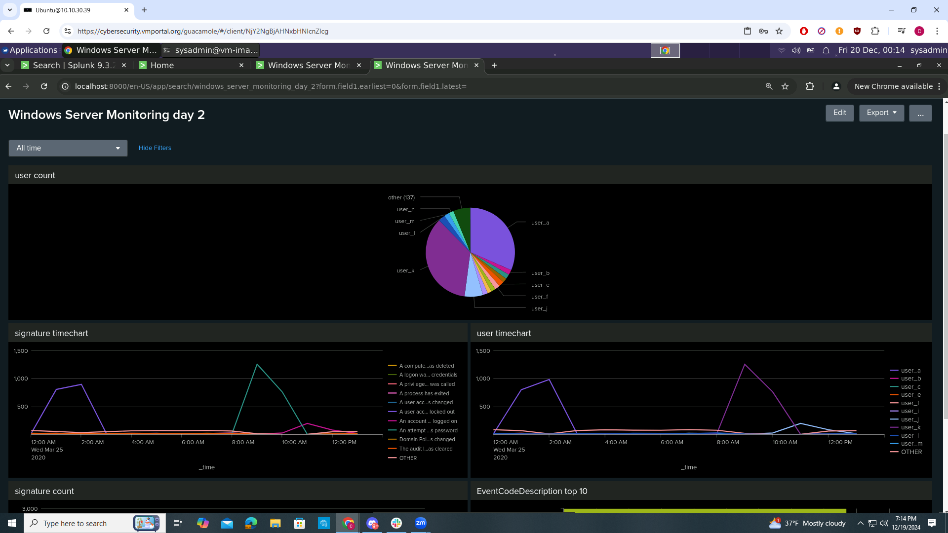

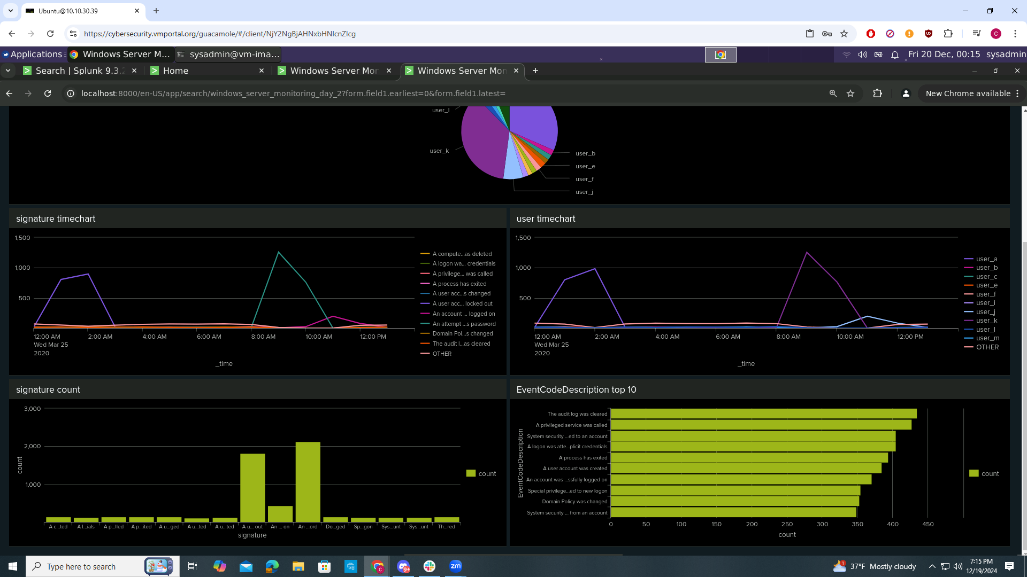

**Report Analysis for Severity**

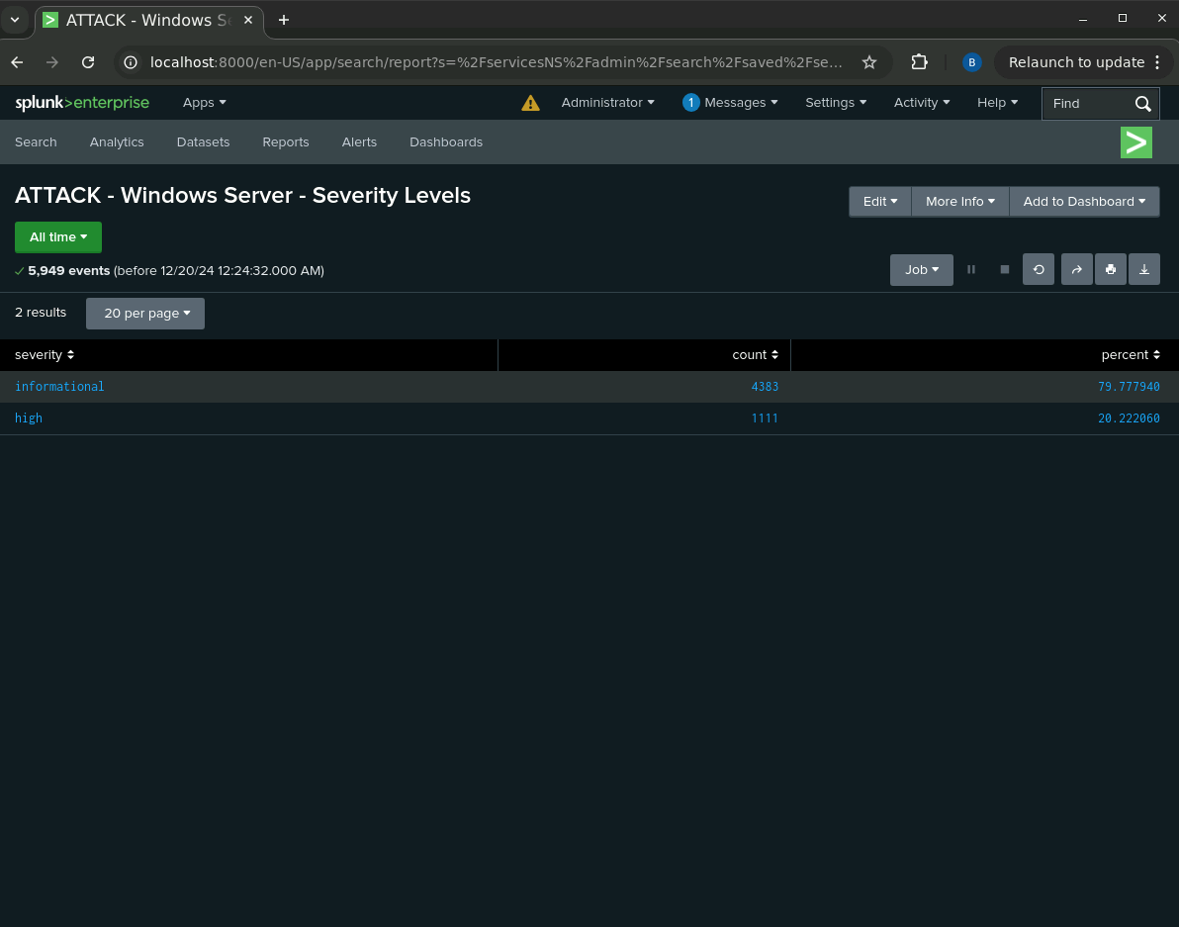

**Report Analysis for failed activities**

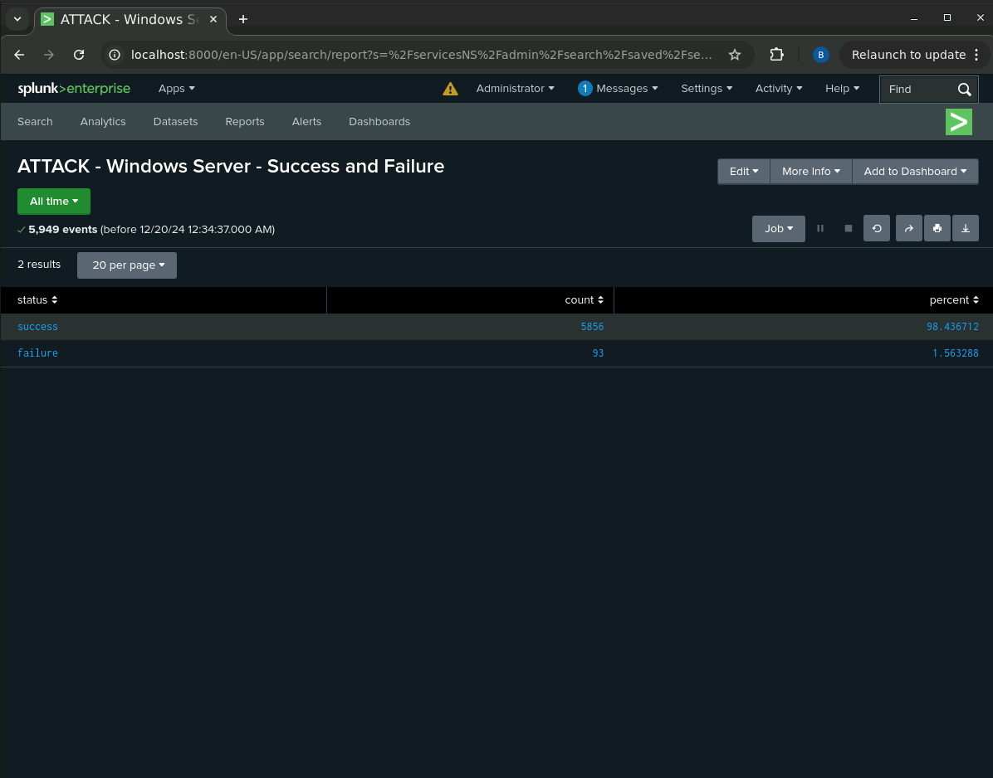

**Alert analysis for failed windows activity**

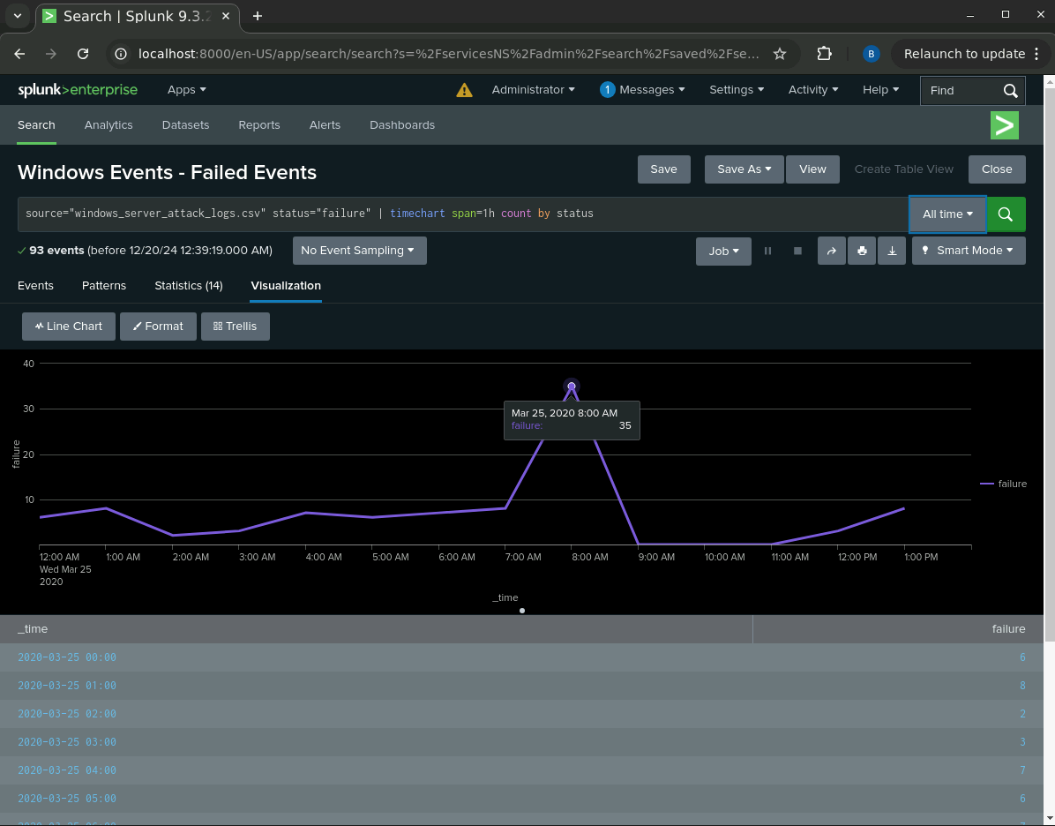

**Alert Analysis for successful Logins**

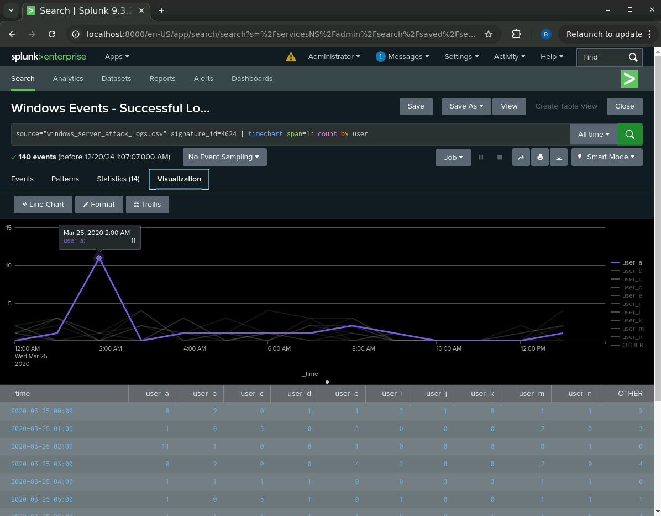

**Alert analysis for Deleted Accounts**

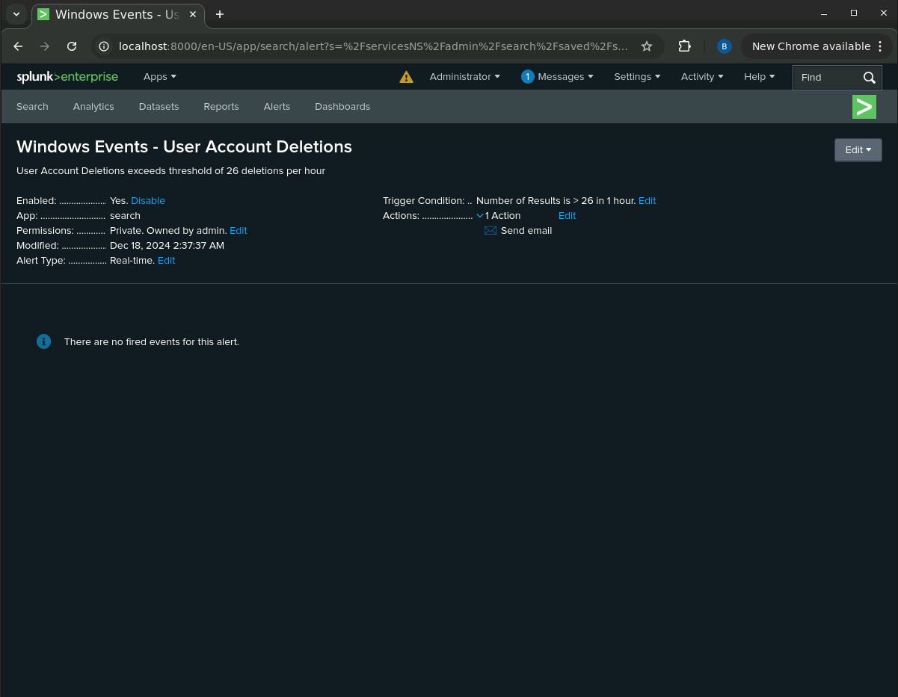

**Dashboard Analysis for Time Chart of Signatures**

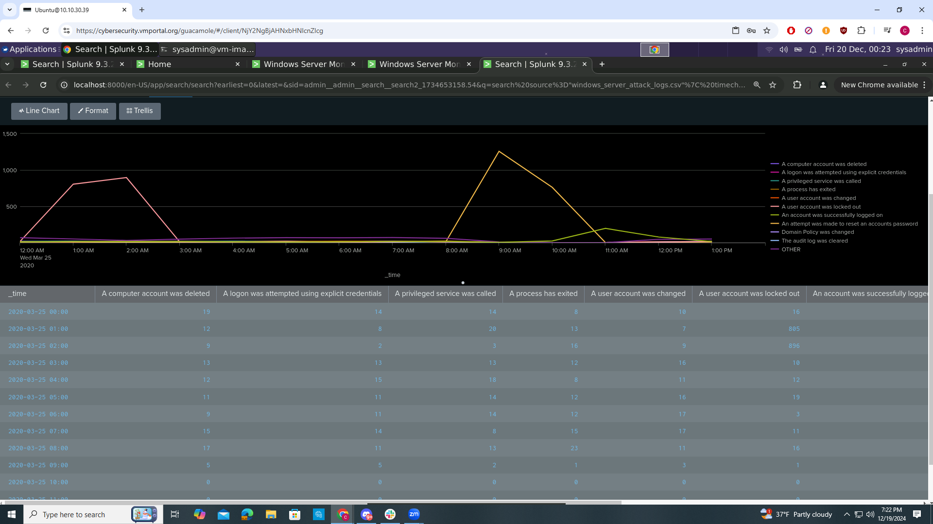

**Dashboard Analysis for Users**

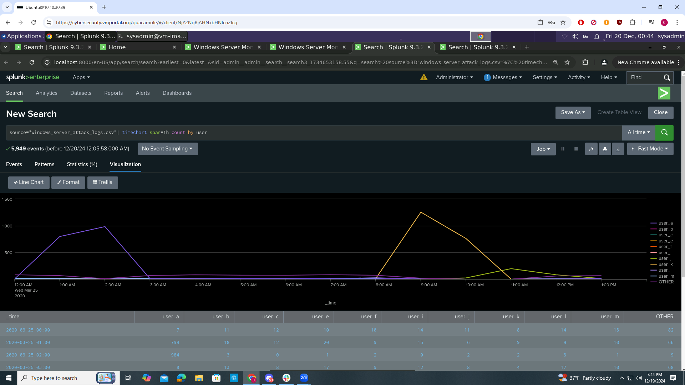

**Dashboard Analysis for Signatures with Bar, Graph, and Pie Charts**

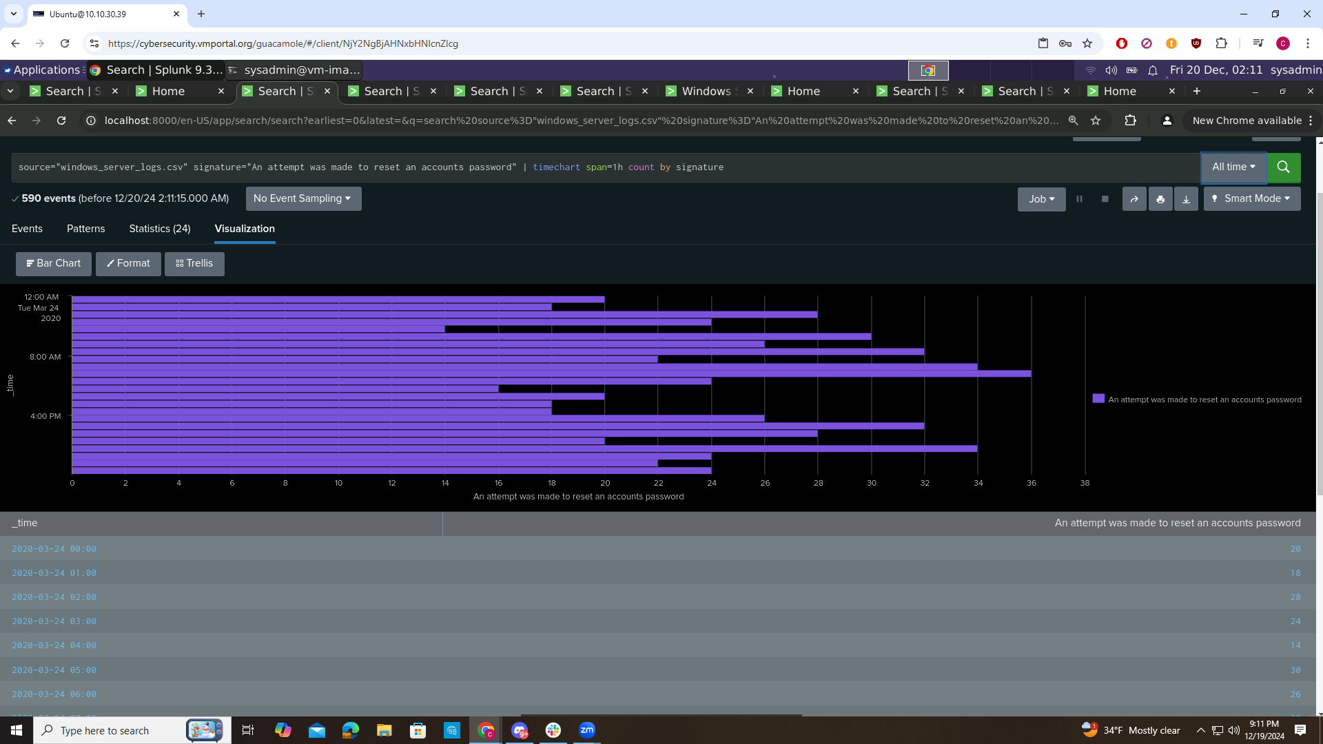

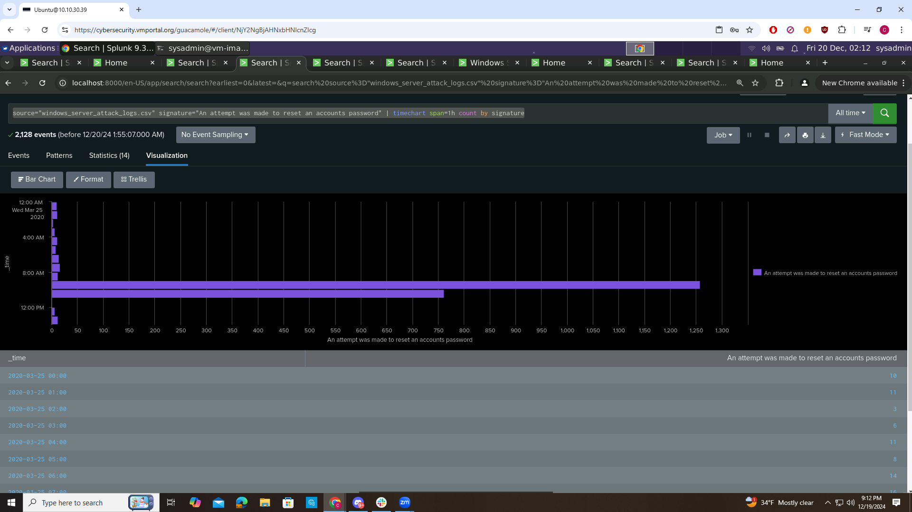

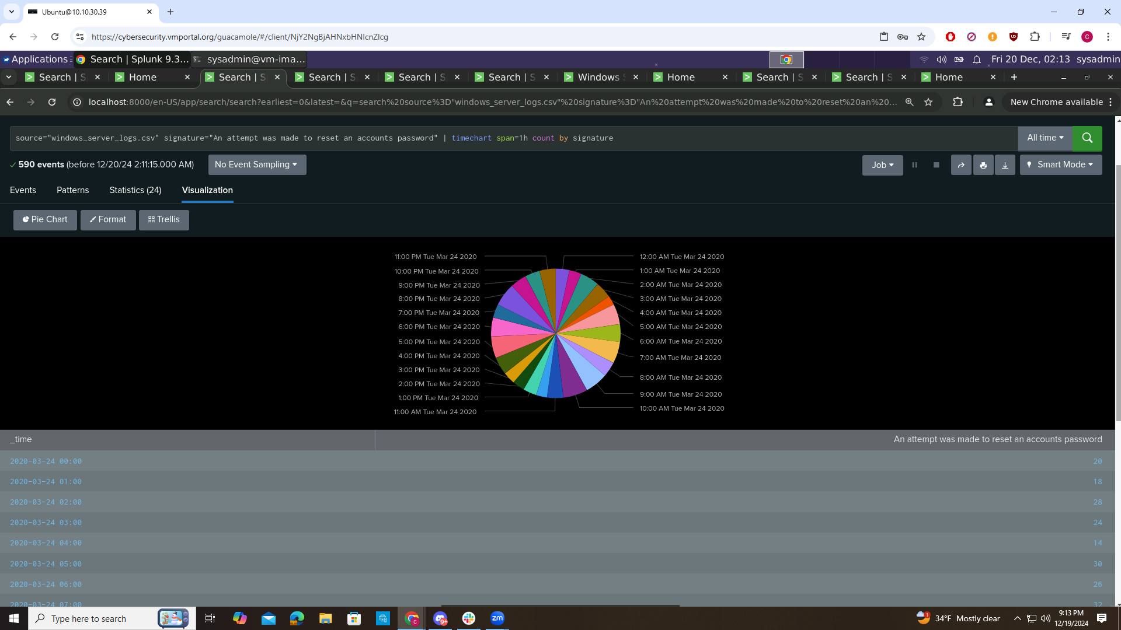

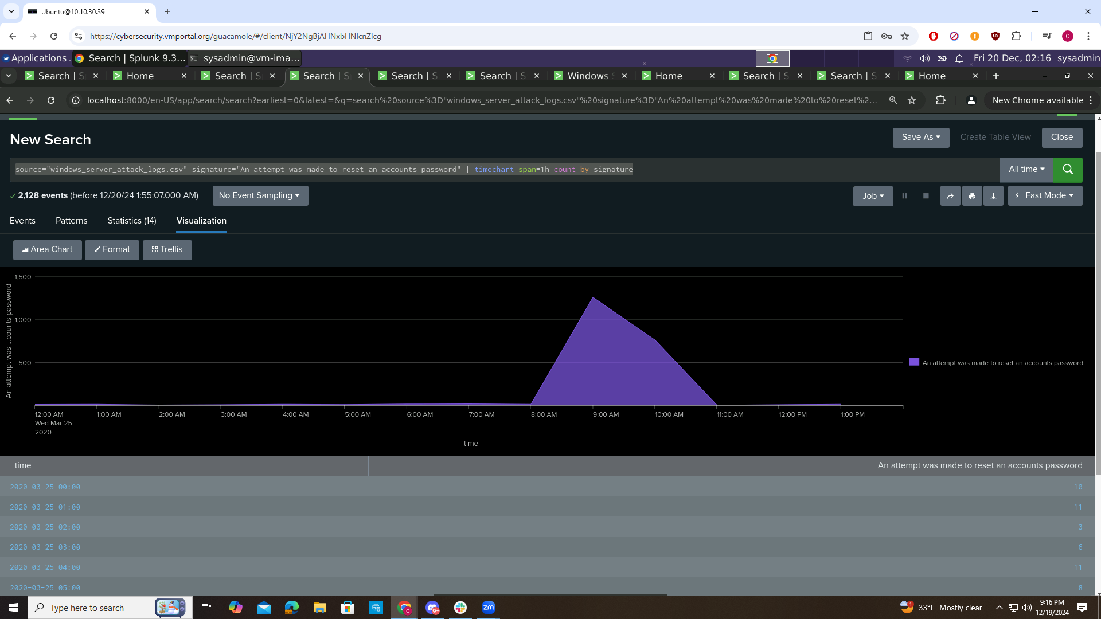

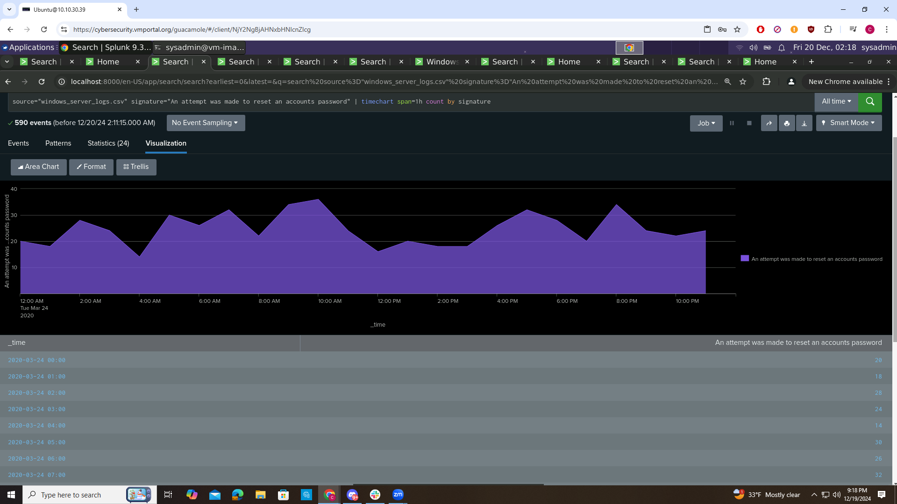

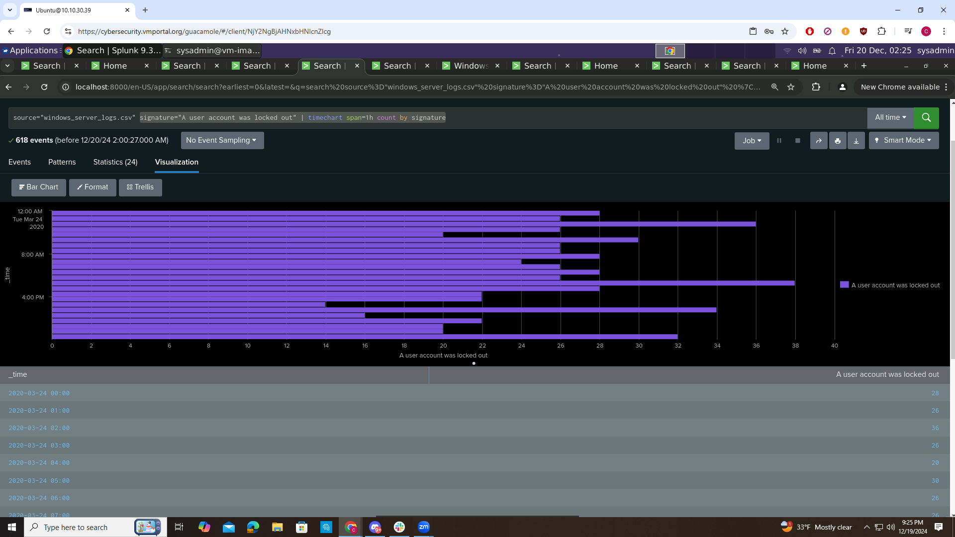

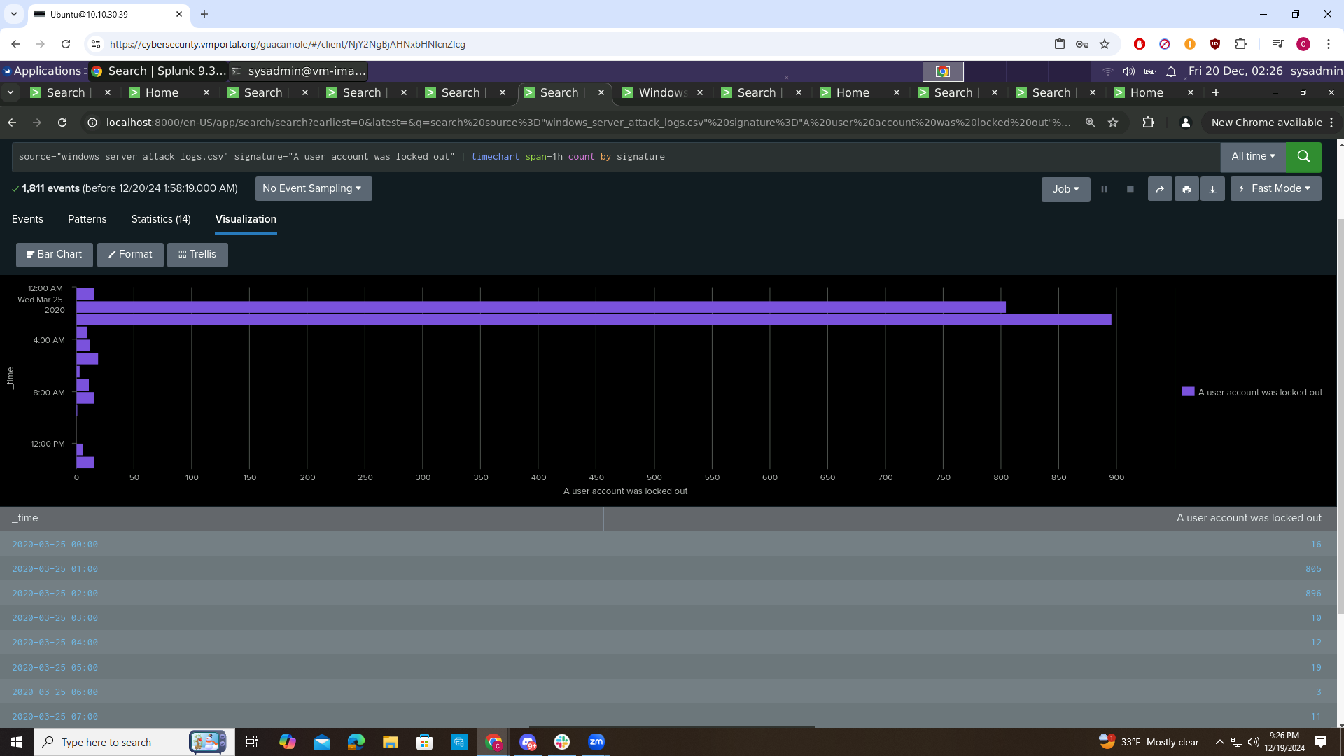

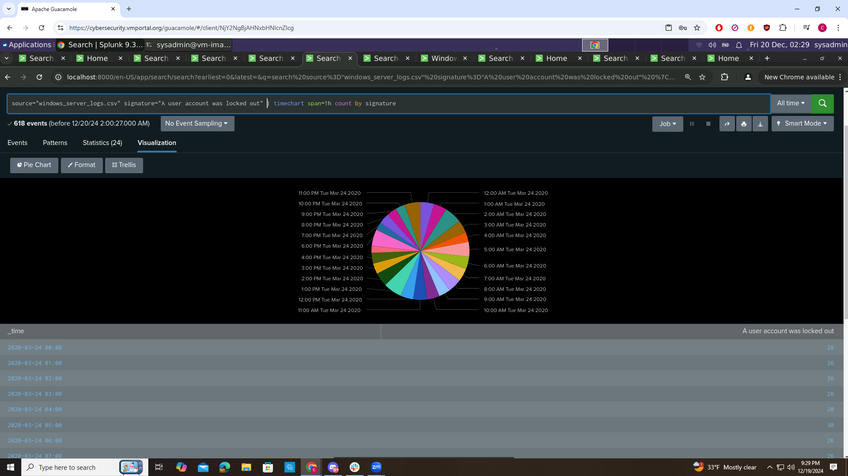

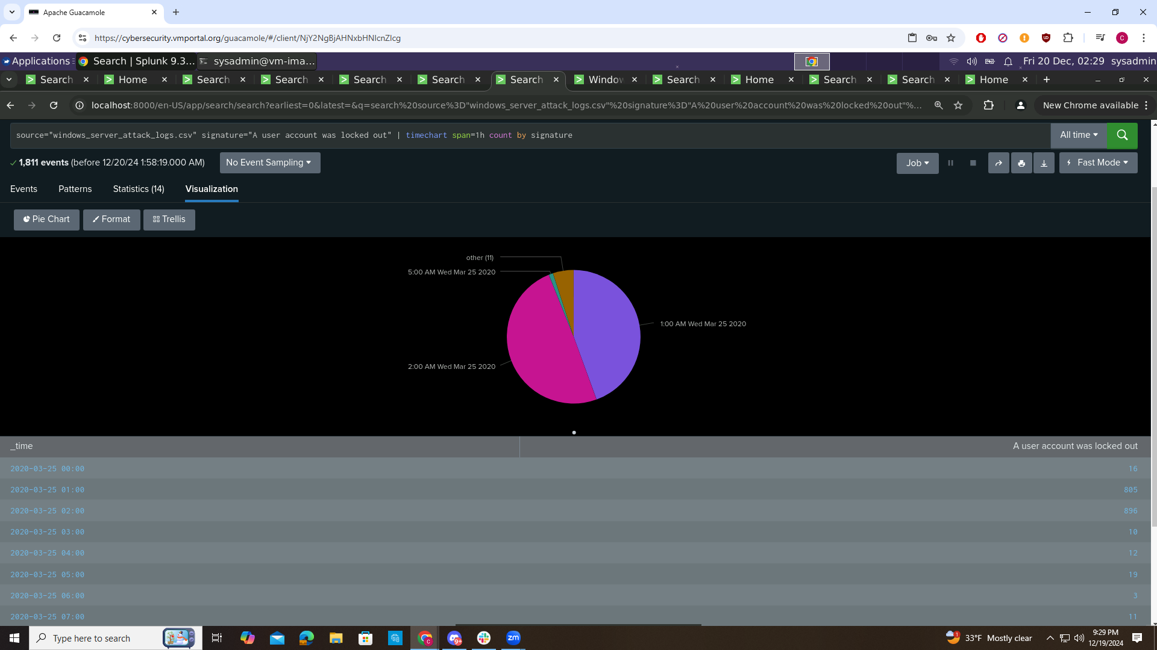

**Dashboard Analysis for users with Bar, Graph, and Pie Charts**

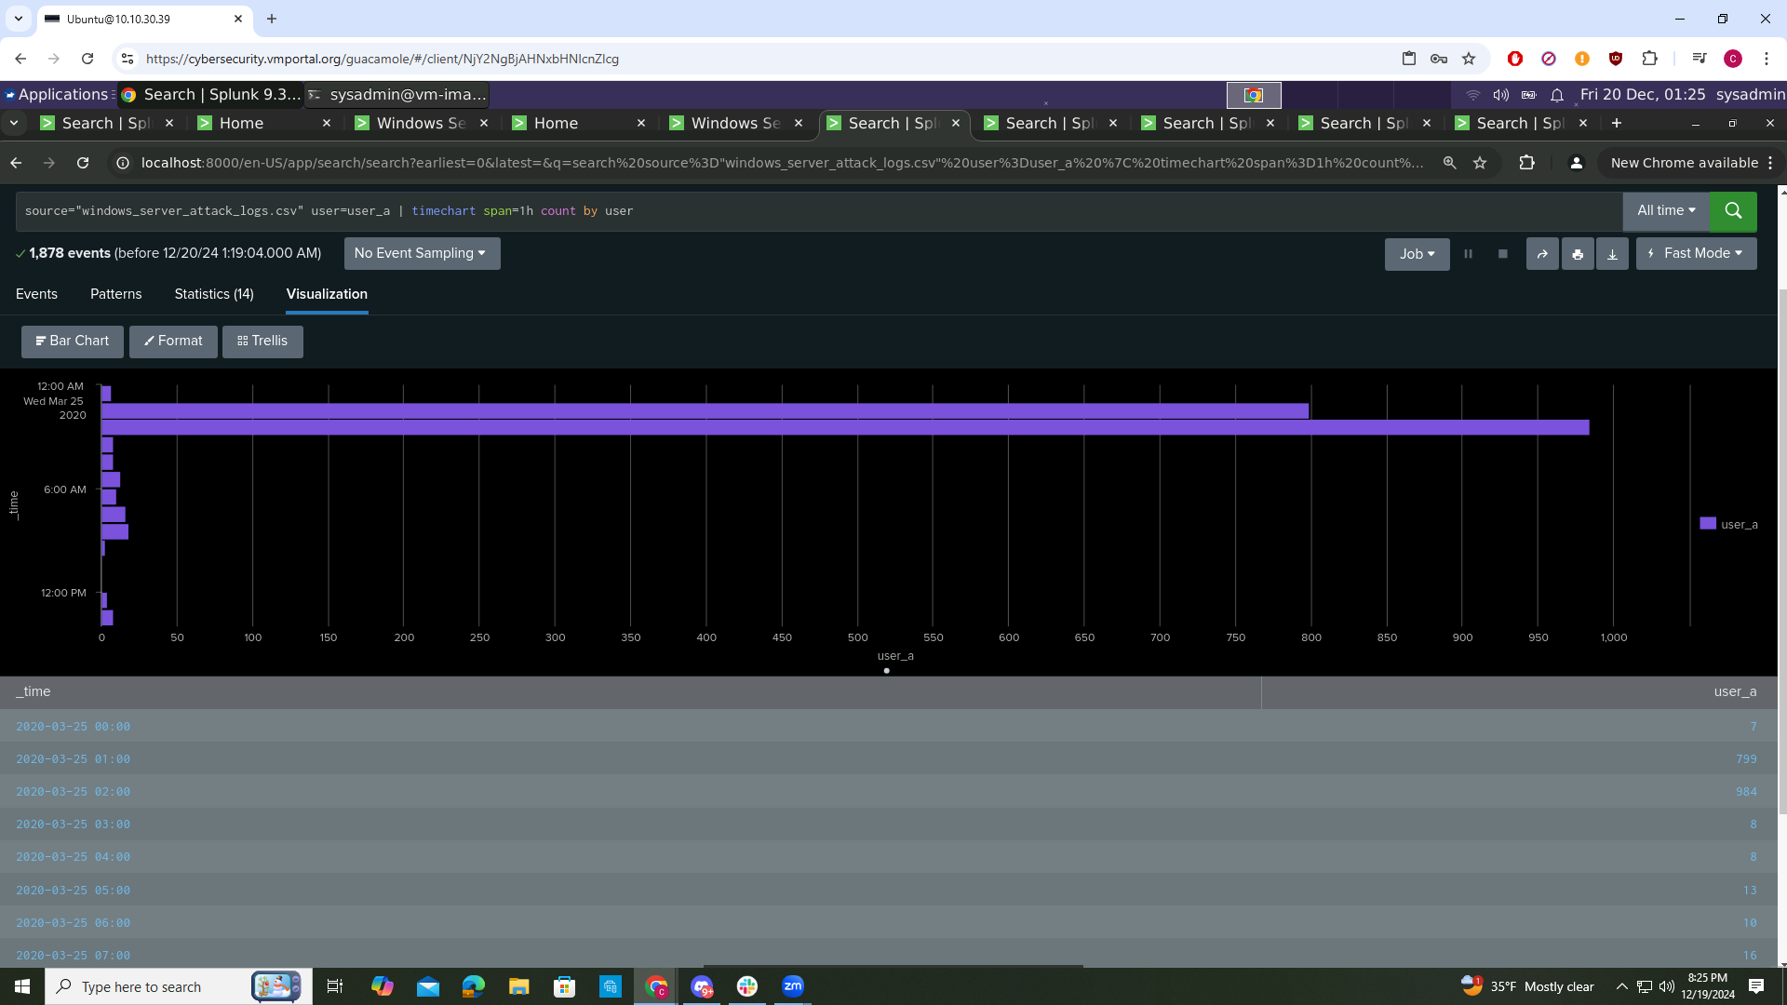

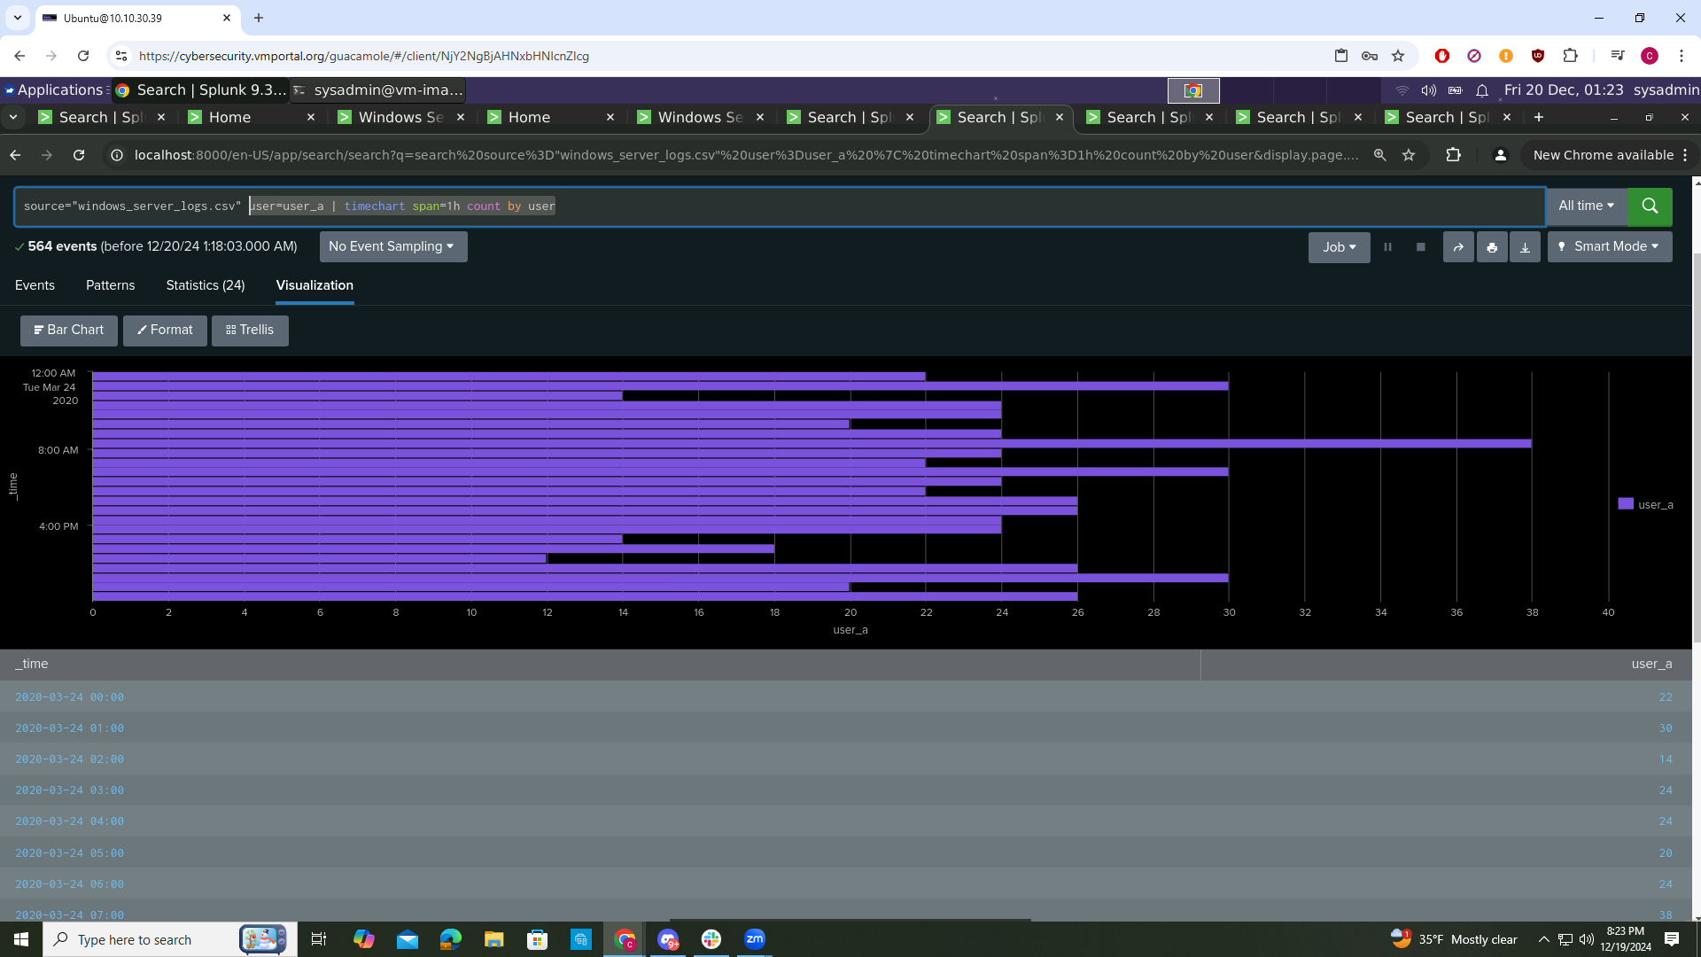

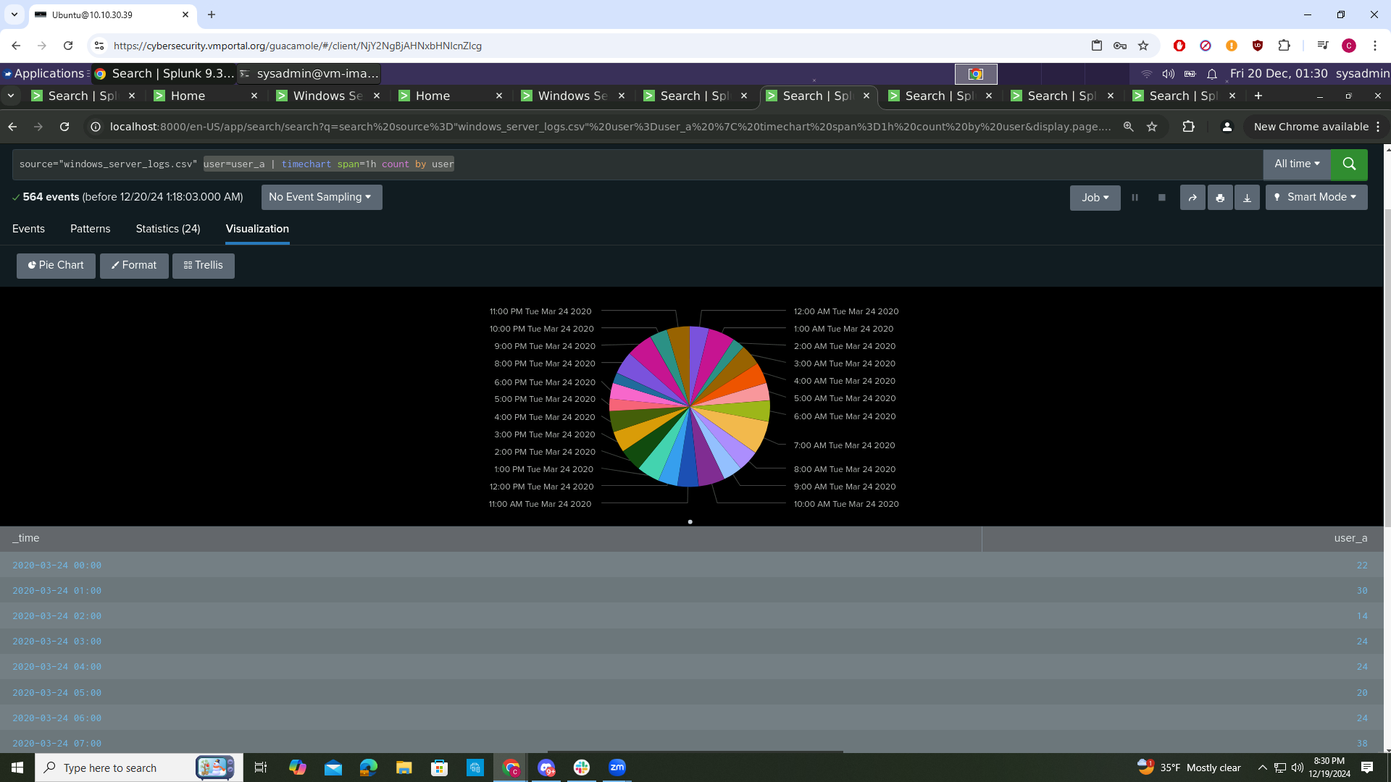

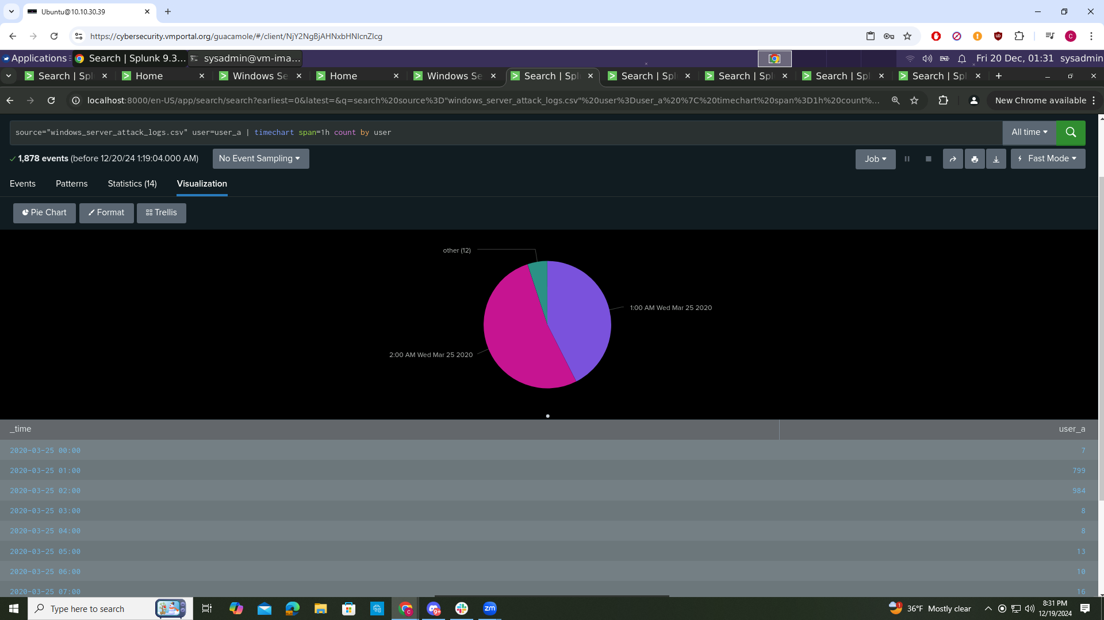

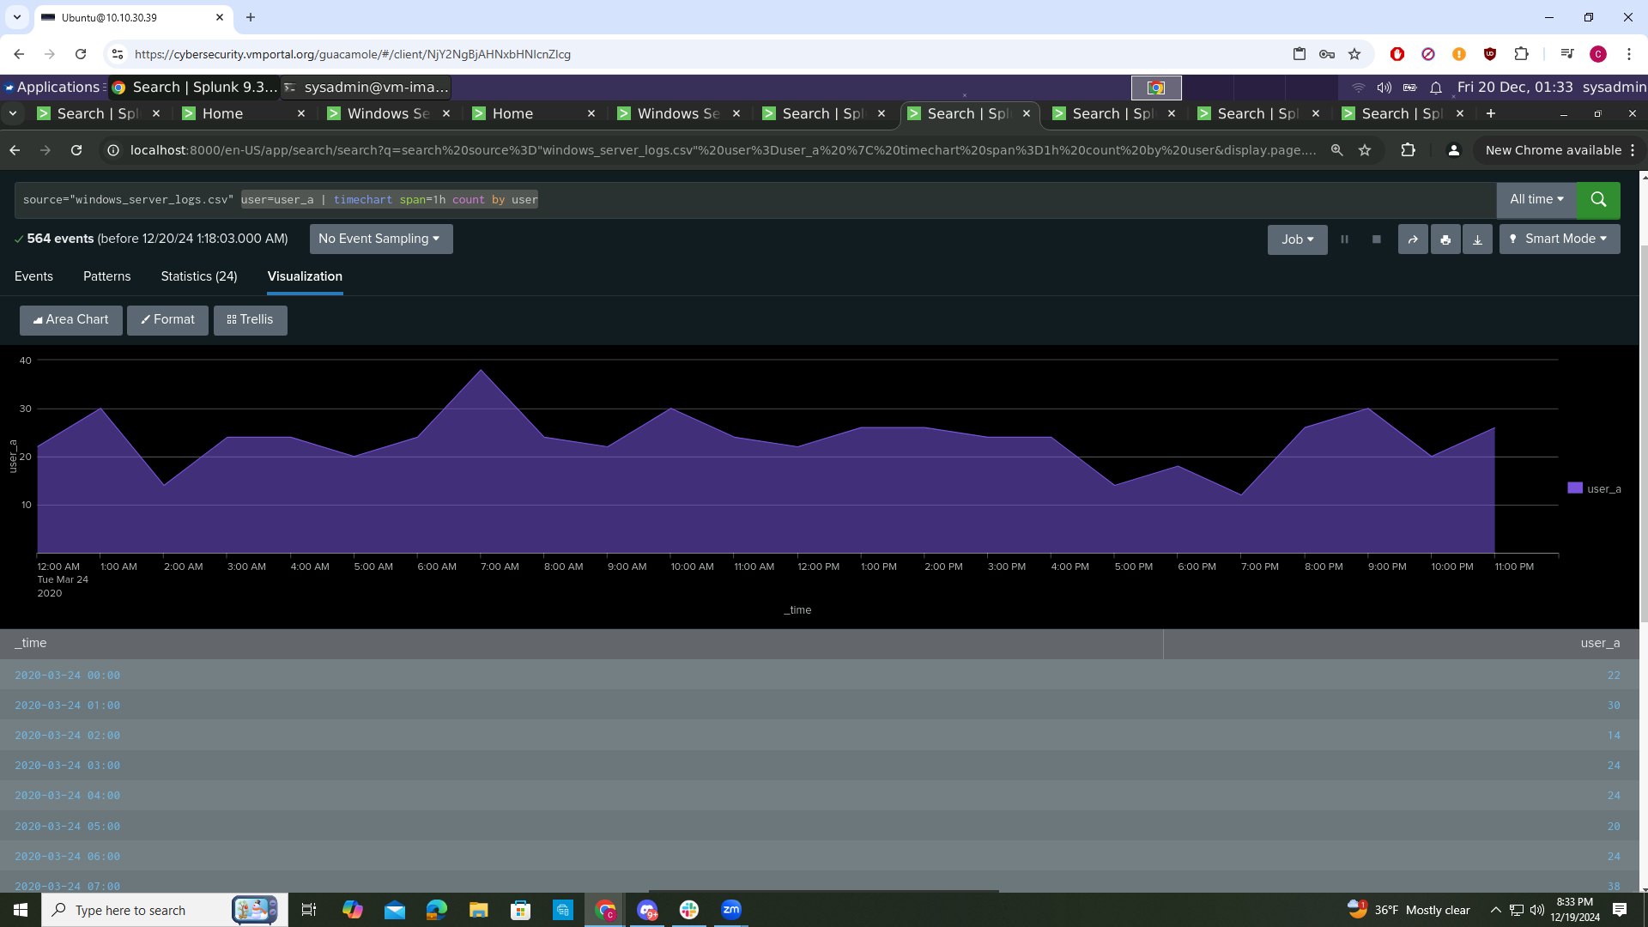

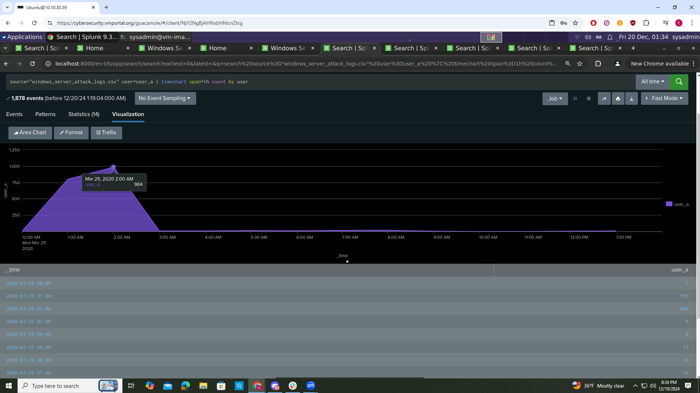

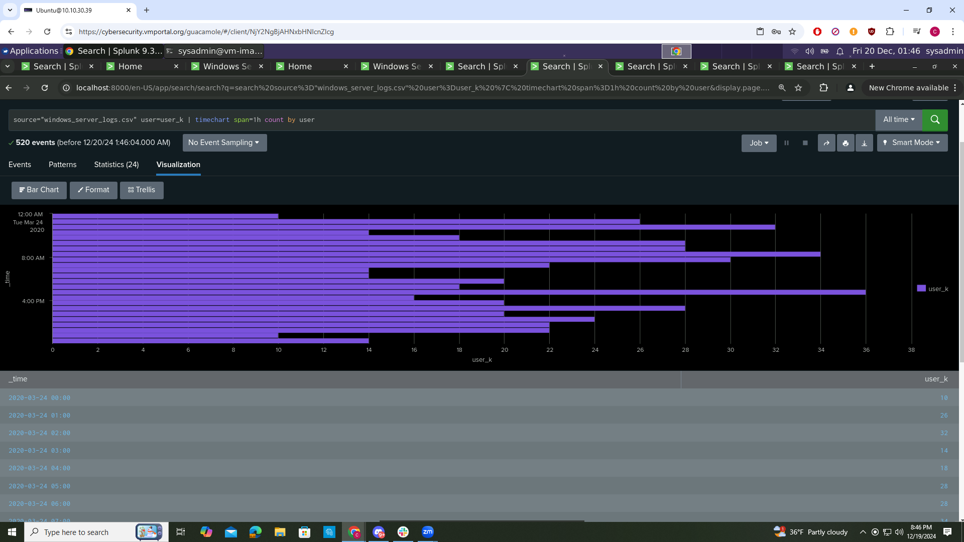

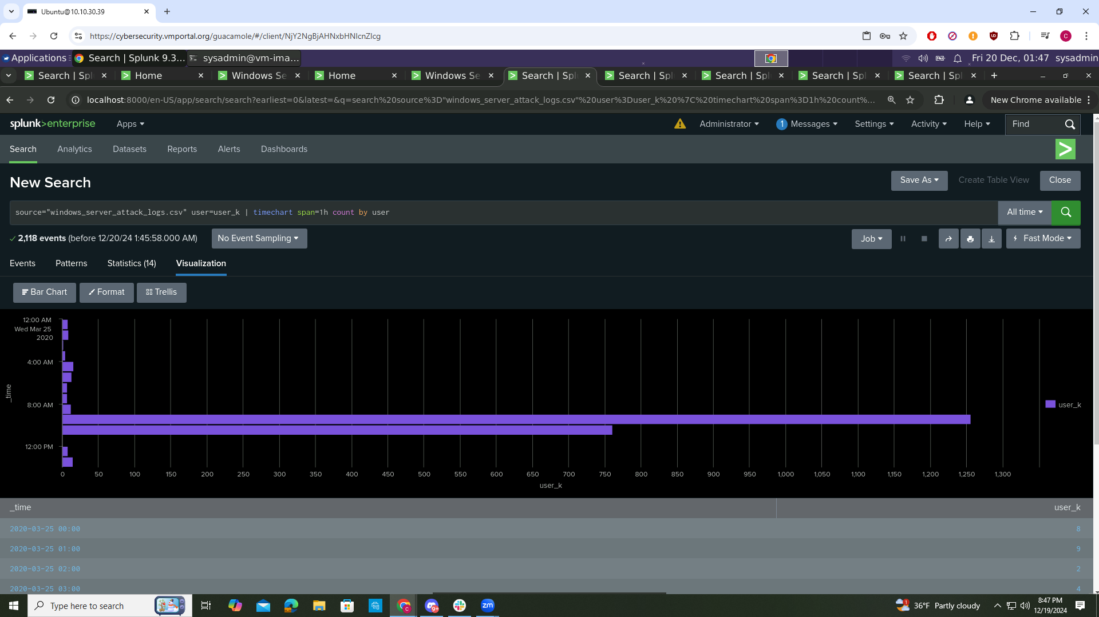

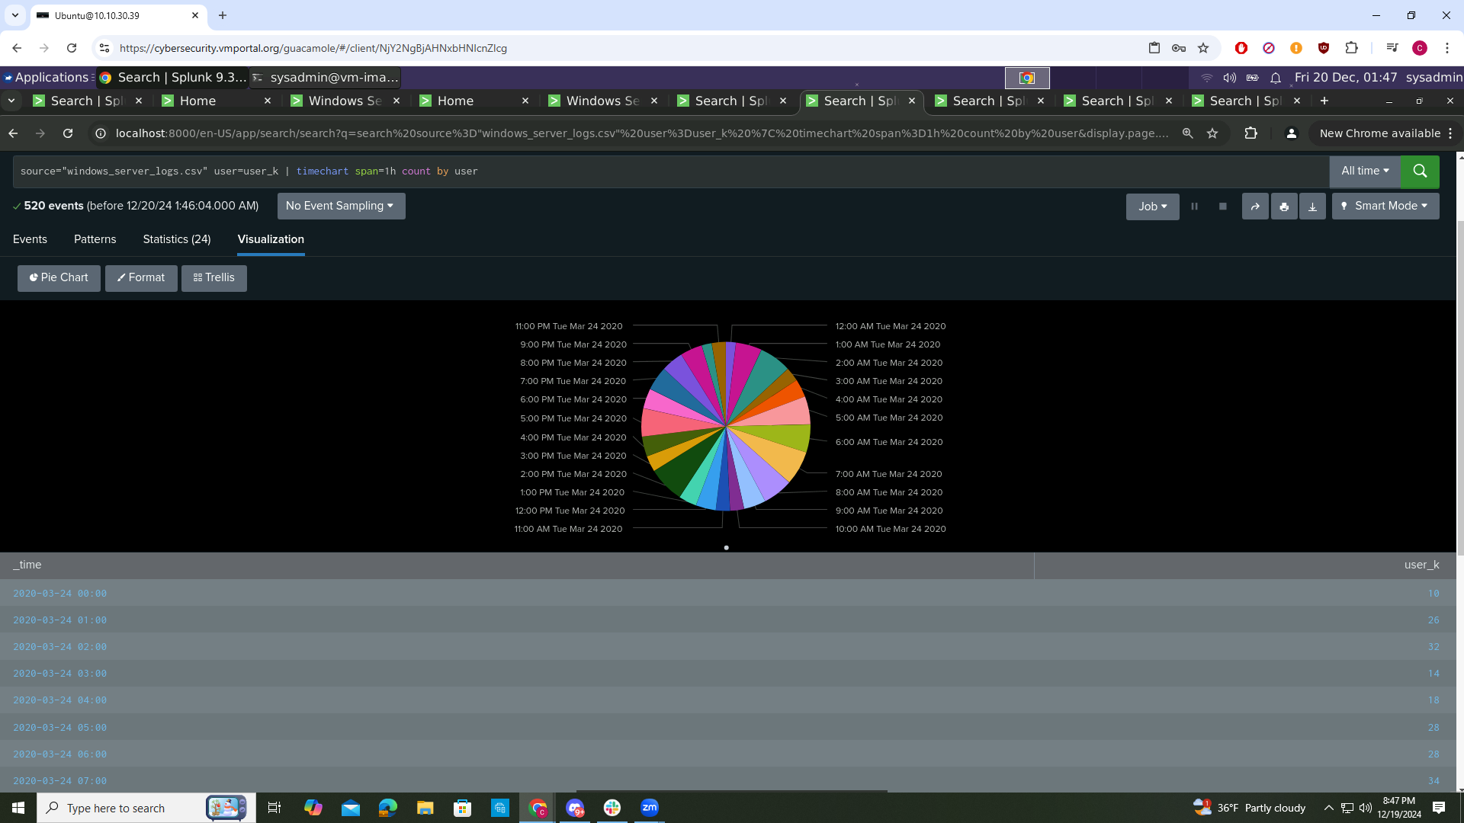

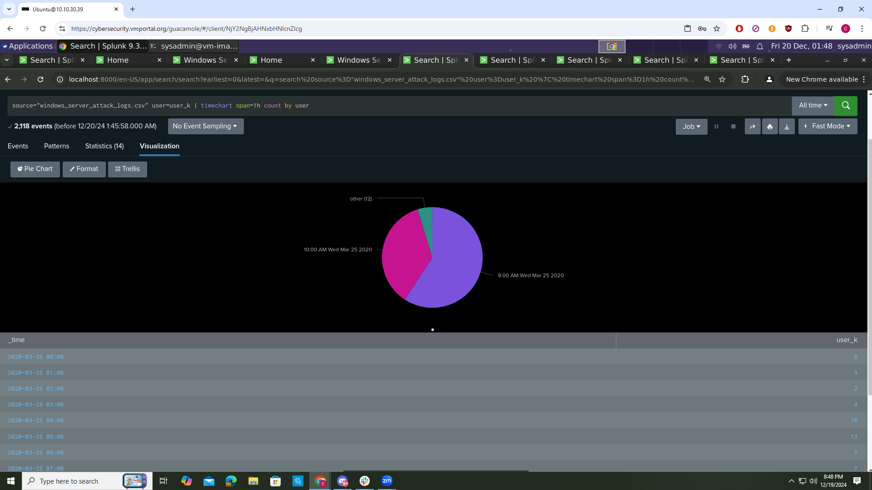

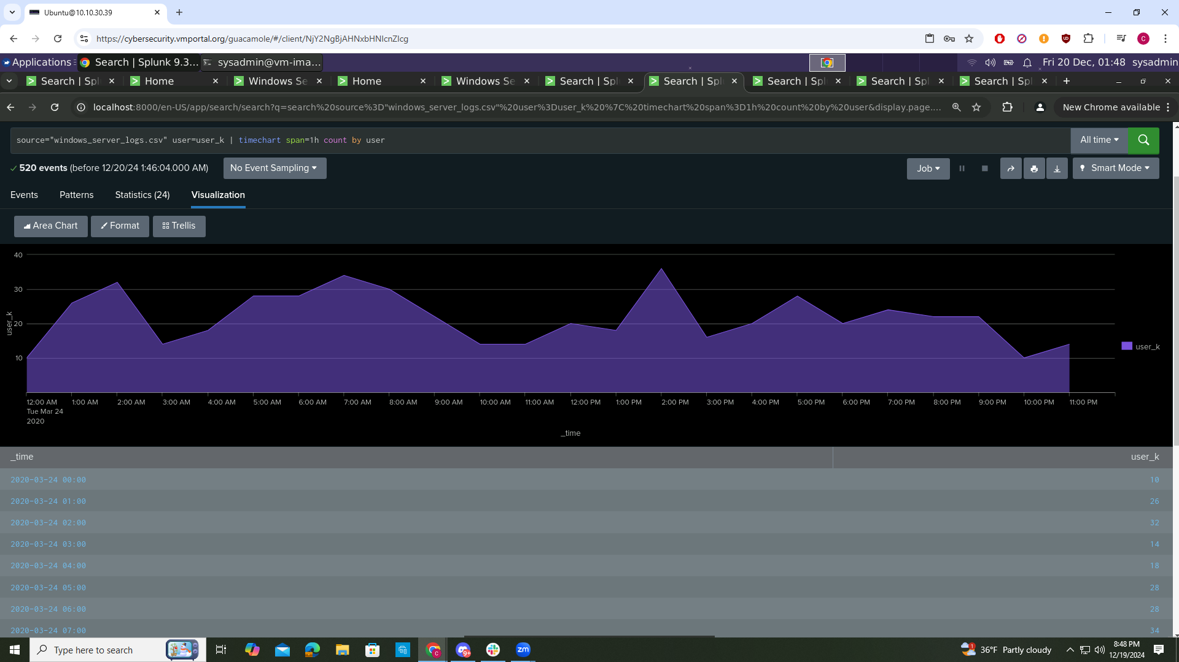

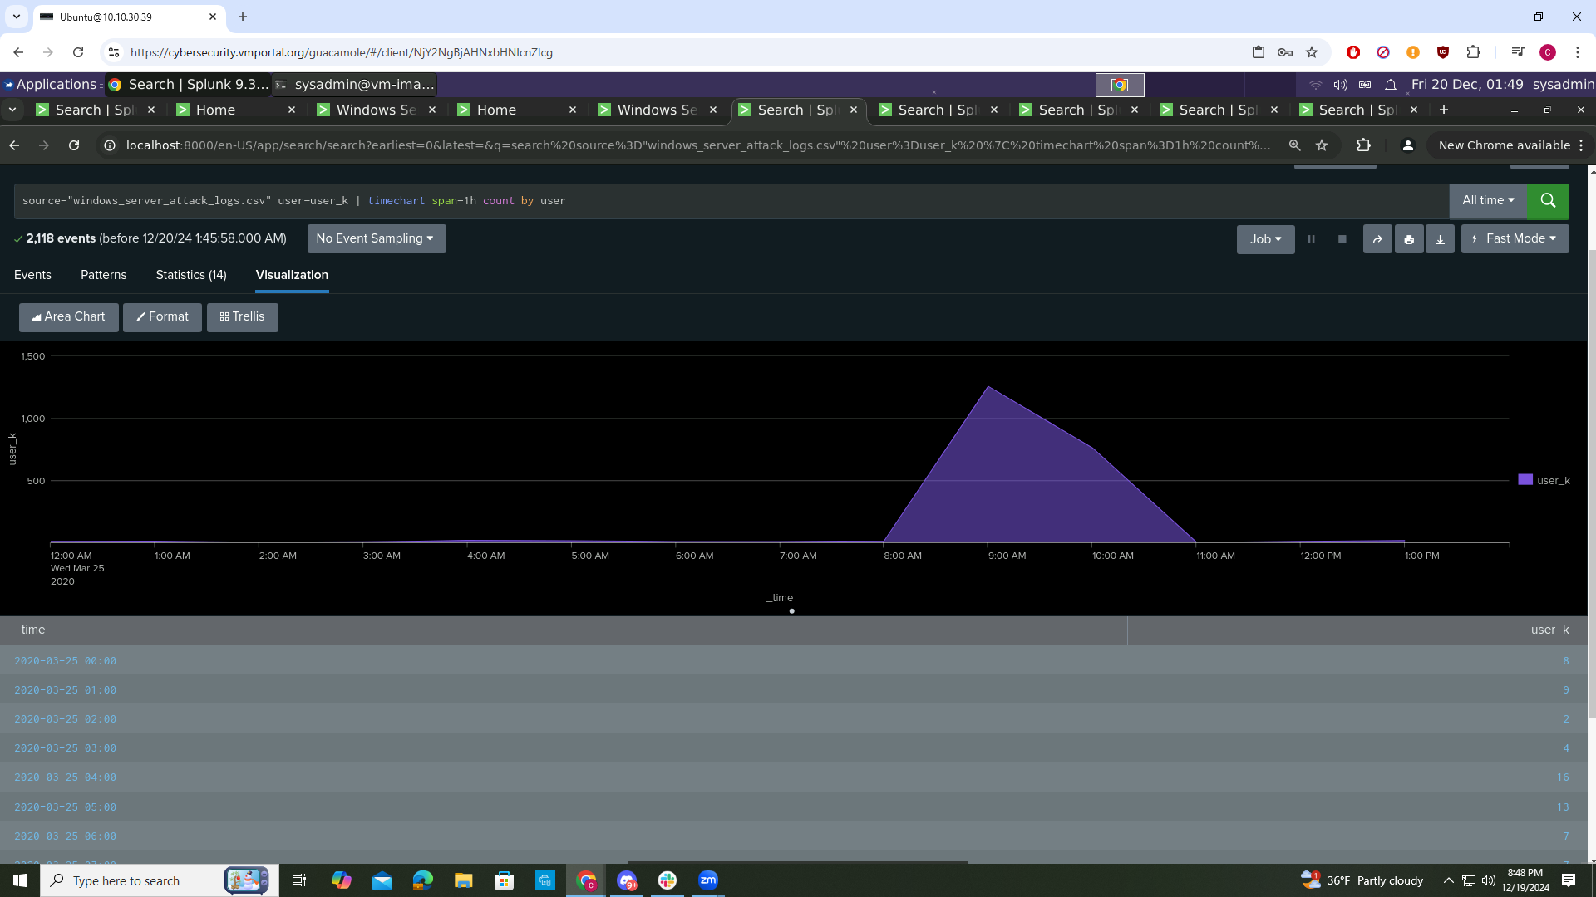

**Dashboard Analysis for Users with Statistical Charts**

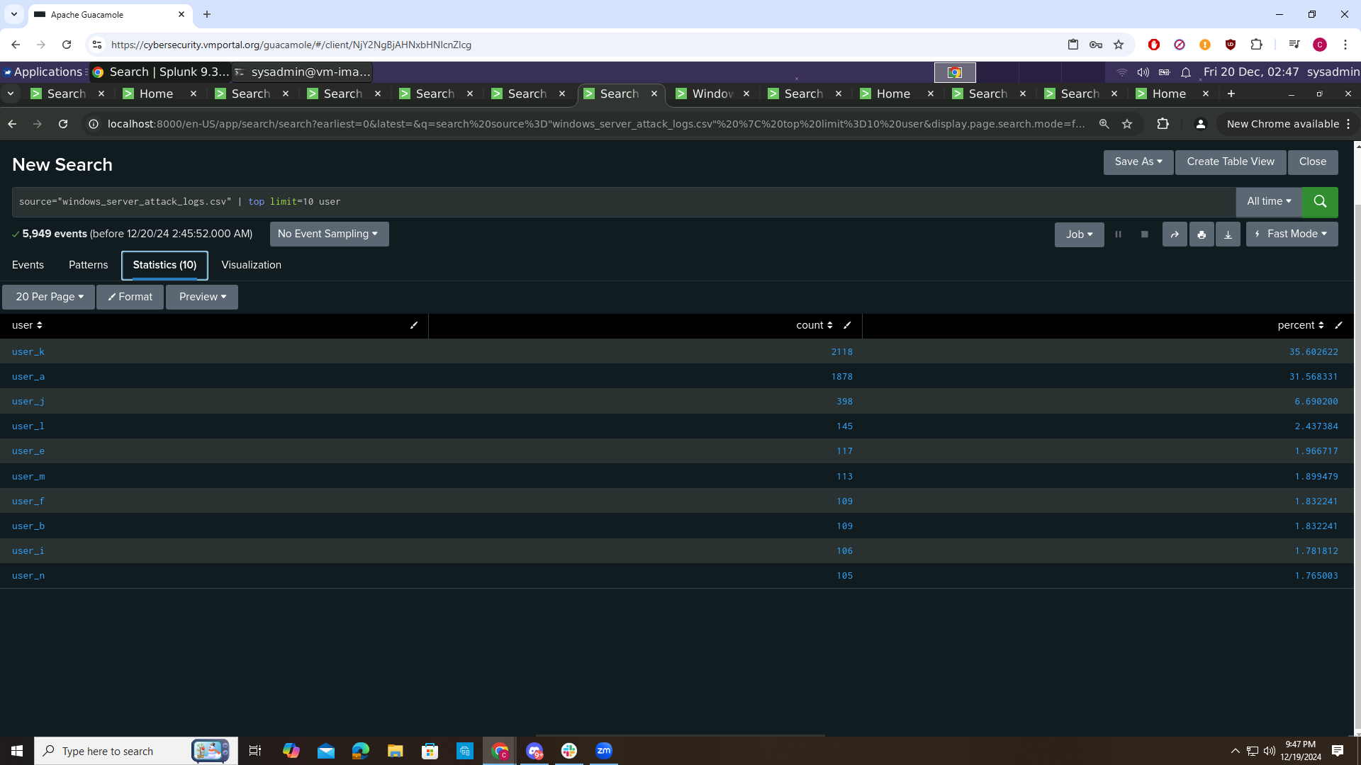

## Apache Server

**Report Analysis for Methods**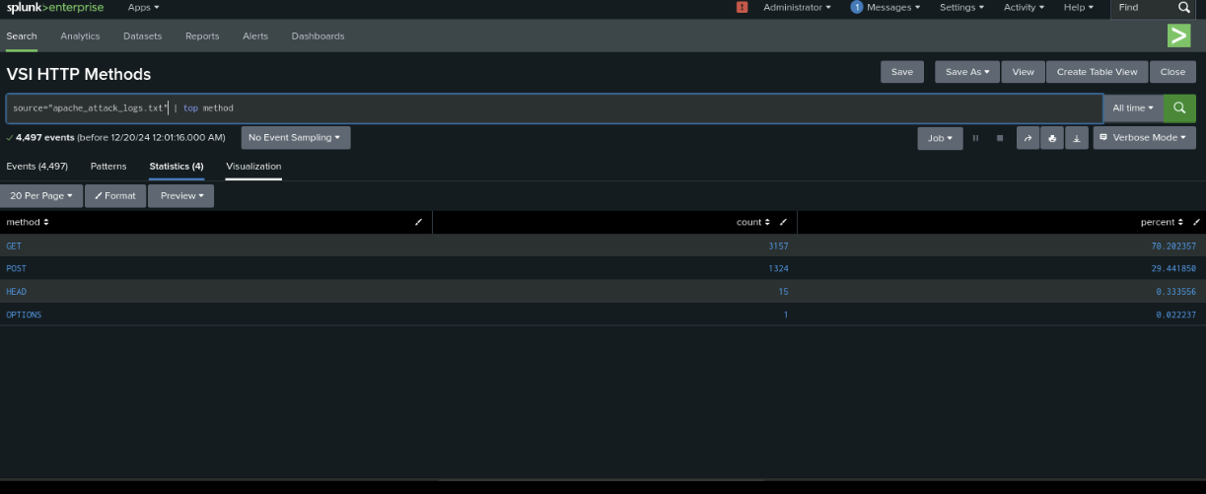

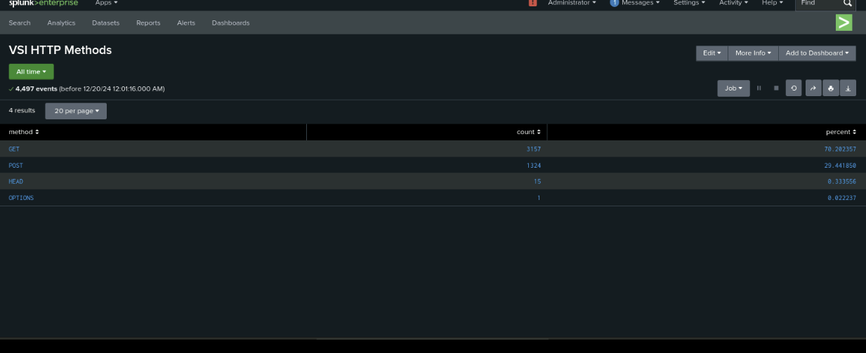

**Report Analysis for Referrer Domains**

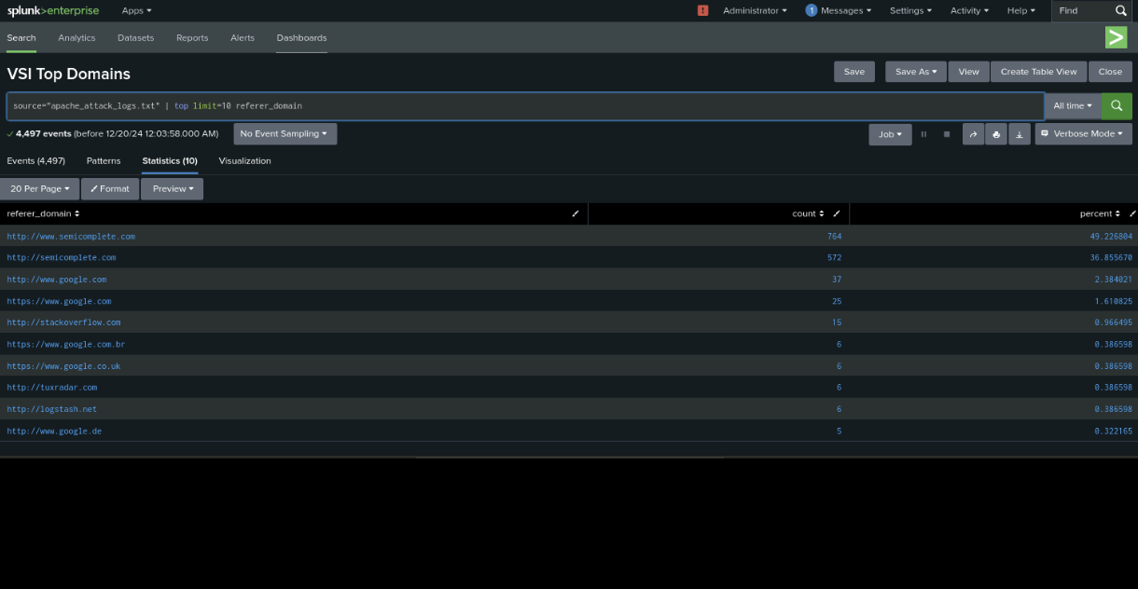

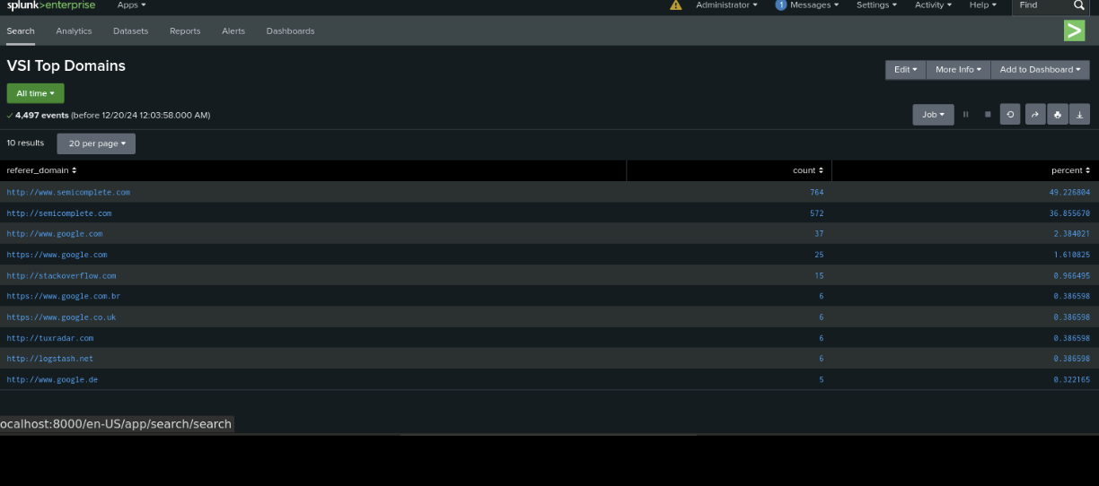

**Report Analysis for HTTP Response Codes**

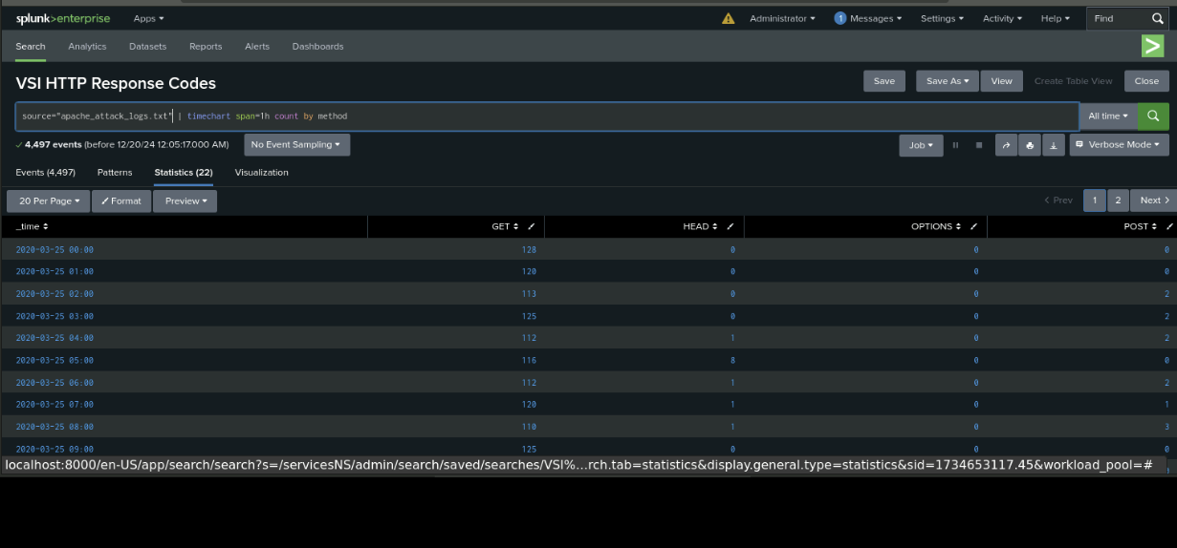

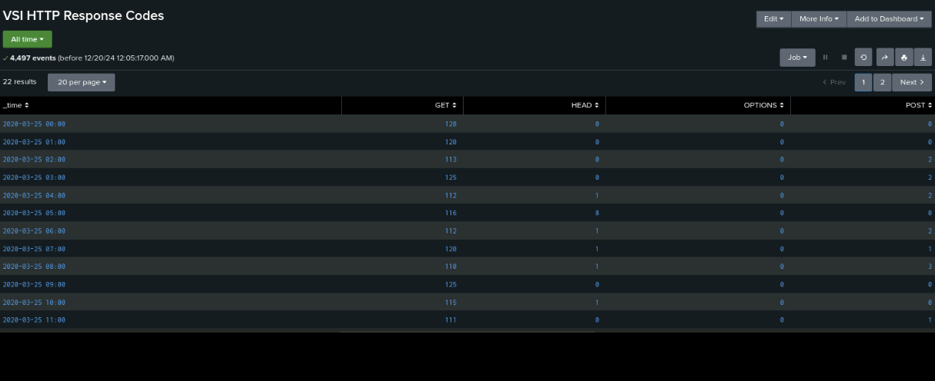

**Alert Analysis for International Activity**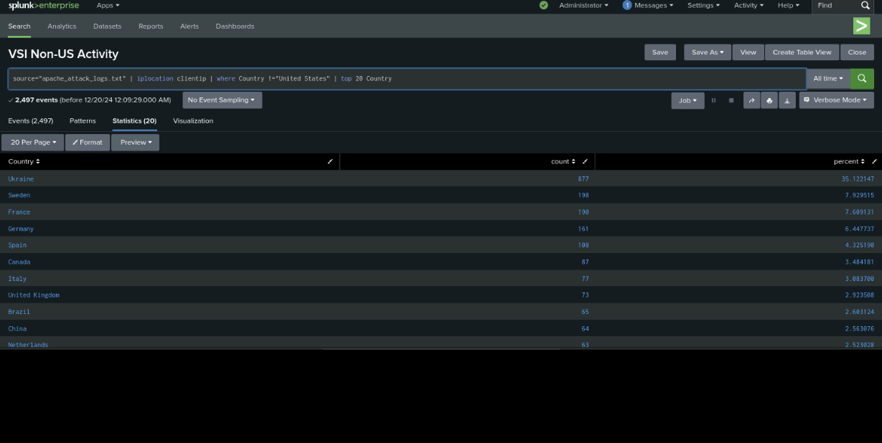

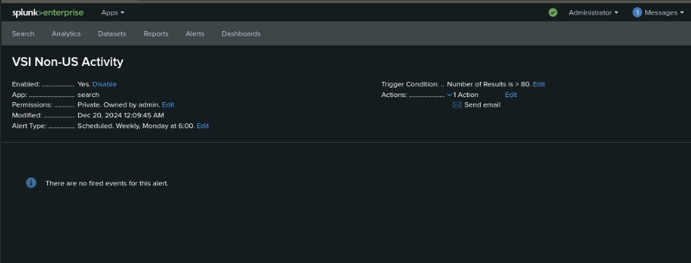

**Alert Analysis for HTTP Post Activity**

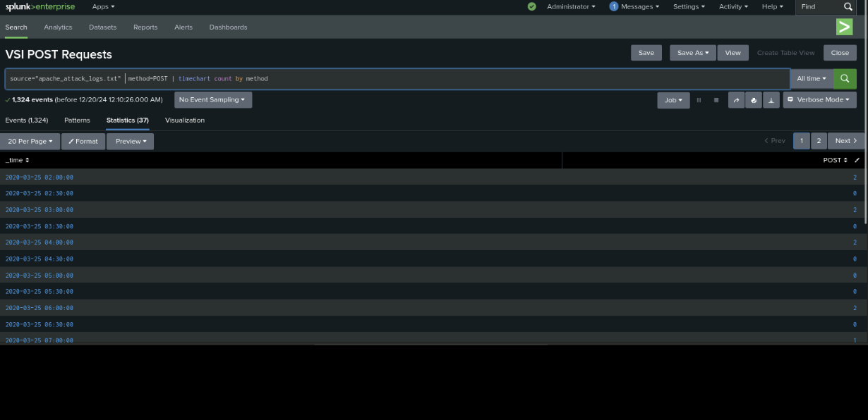

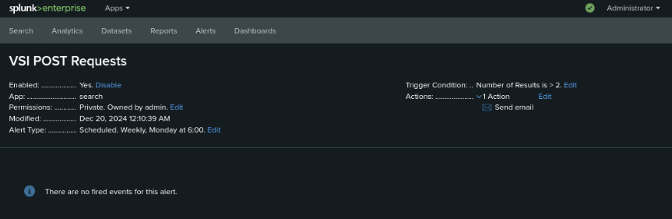

**Dashboard Analysis for Time Chart of HTTP Methods**

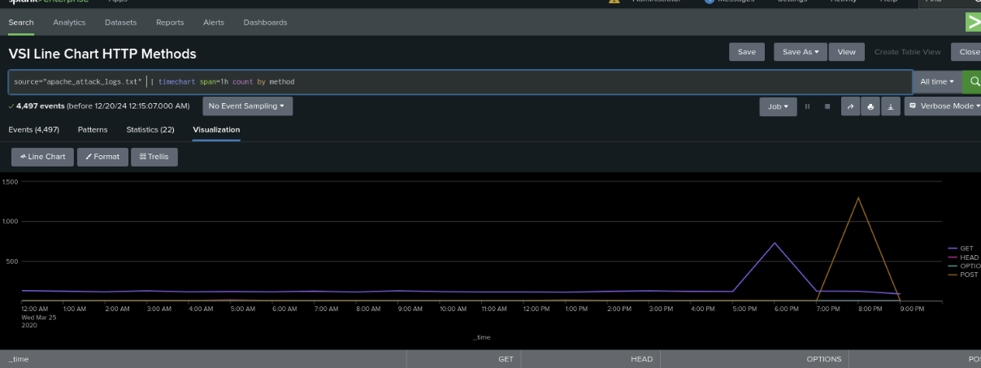

**Dashboard Analysis for Cluster Map**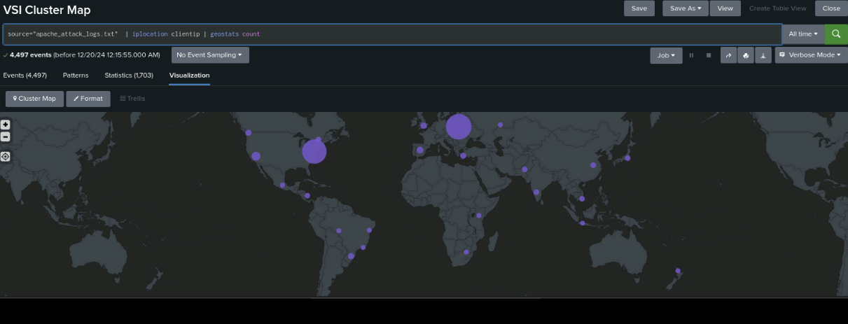

**Dashboard Analysis for URI Data**

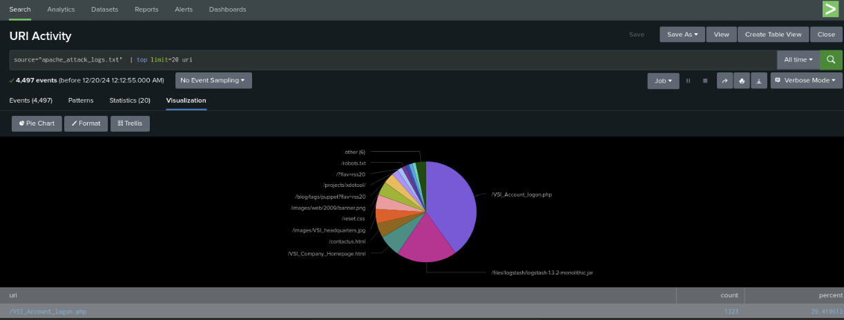

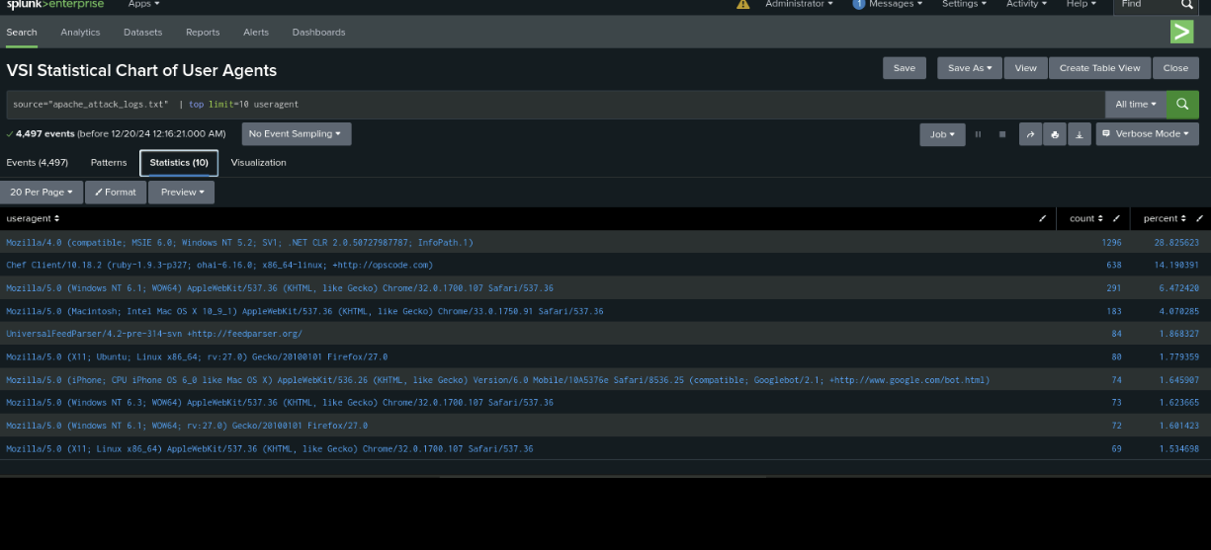

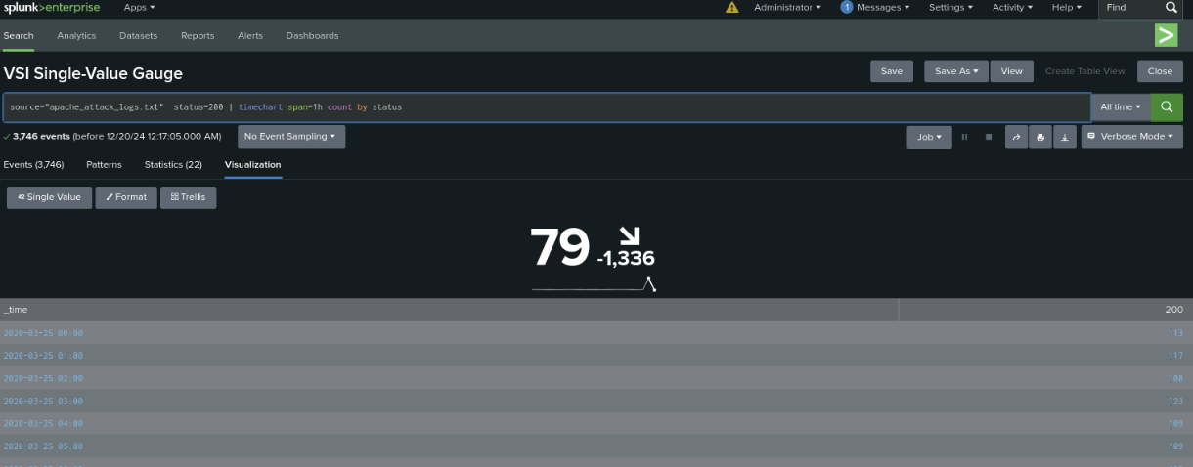

## Others

A single-value visualization of your choice that analyzes any single data point: e.g., radial gauge, marker gauge, or a custom visualization from h[ttp://localhost:8000/en-US/manager/search/appsremote?content=visualizations&type=app](http://localhost:8000/en-US/manager/search/appsremote?content=visualizations&type=app)).



On your dashboard, add the ability to change the time range for all visualizations.

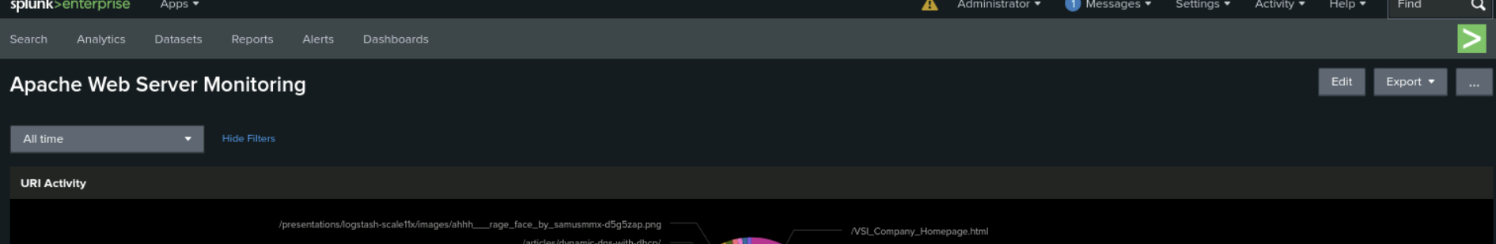

Any visualization of your choice that displays the number of different URIs.

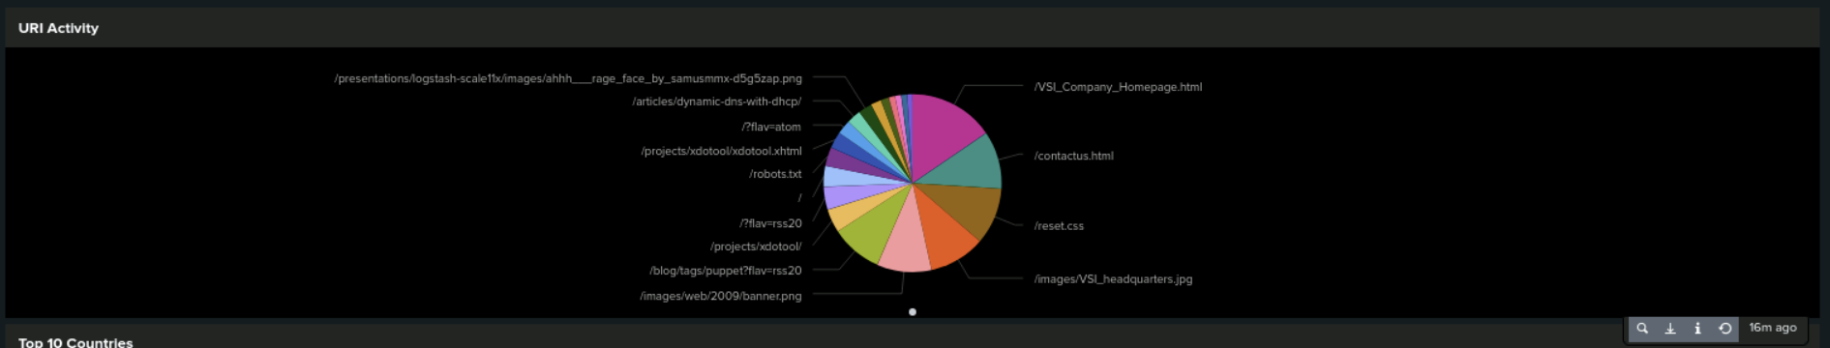

Any visualization of your choice that displays the count of the top 10 countries that appear in the log.

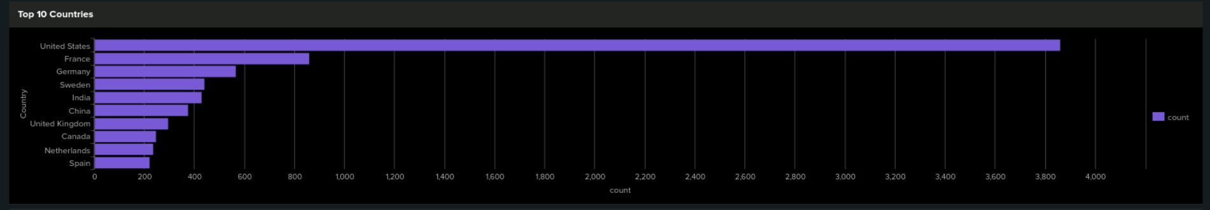

Any visualization that illustrates the count of different user agents.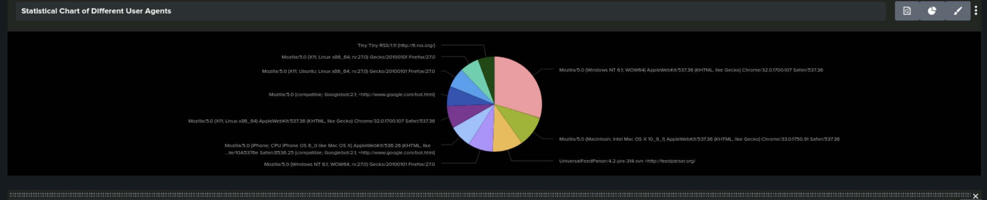

A report that shows the top 10 domains that refer to VSI’s website.

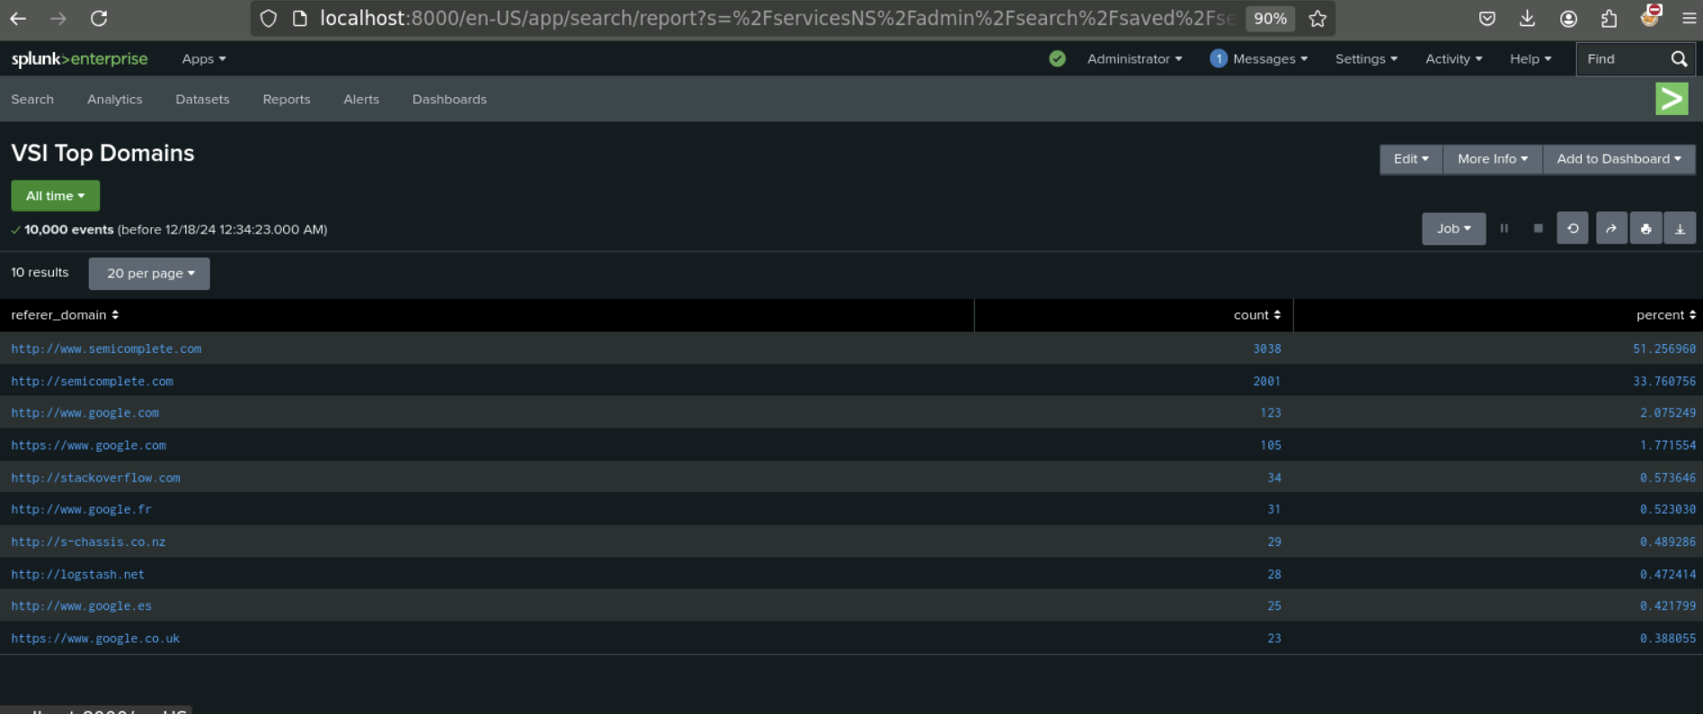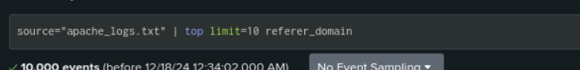

baseline and threshold for the hourly count of the signature “a user account was deleted.” : Average = 13 user accounts deleted per hour, Maximum = 22 user accounts deleted per hour, Recommended Threshold = 26 user accounts deleted per hour

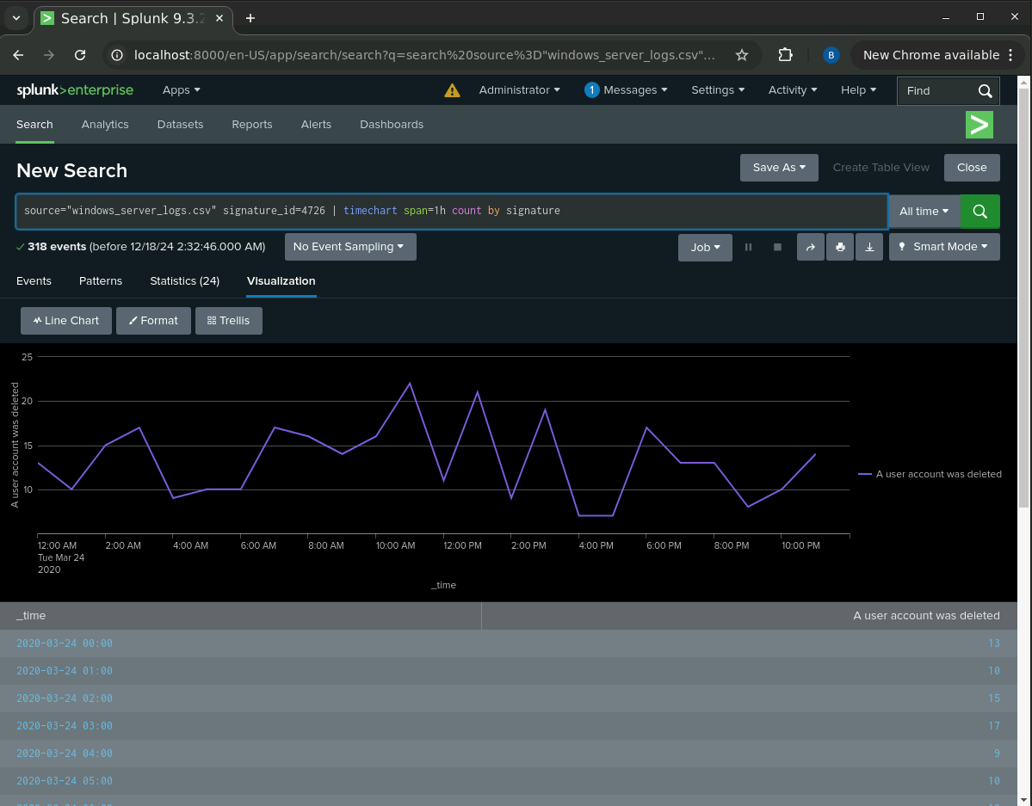

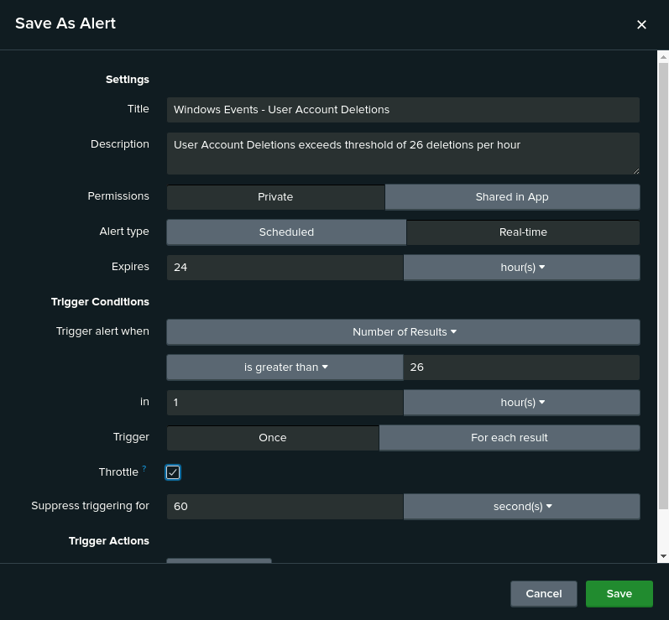

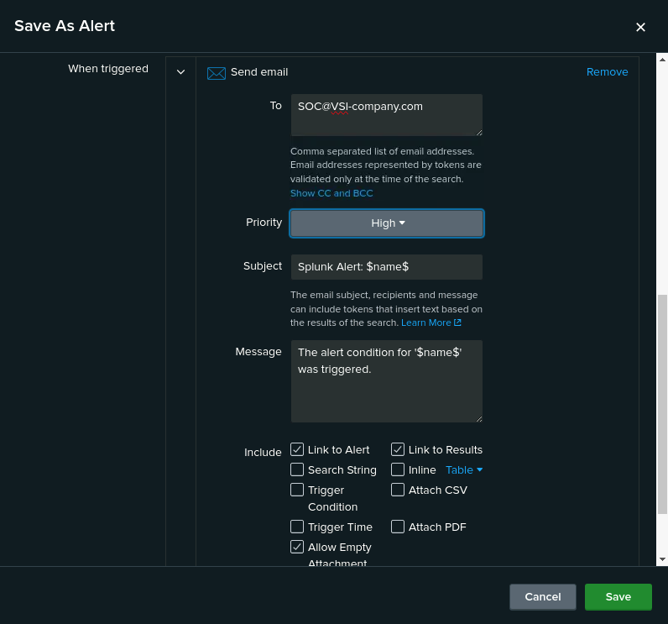

Baseline and threshold for the hourly count of the signature “an account was successfully logged on.” : Average = 3 successful logins per hour per user, Maximum = 6 successful logins per hour by user_a, Recommended Threshold = 8 successful logins per hour per user

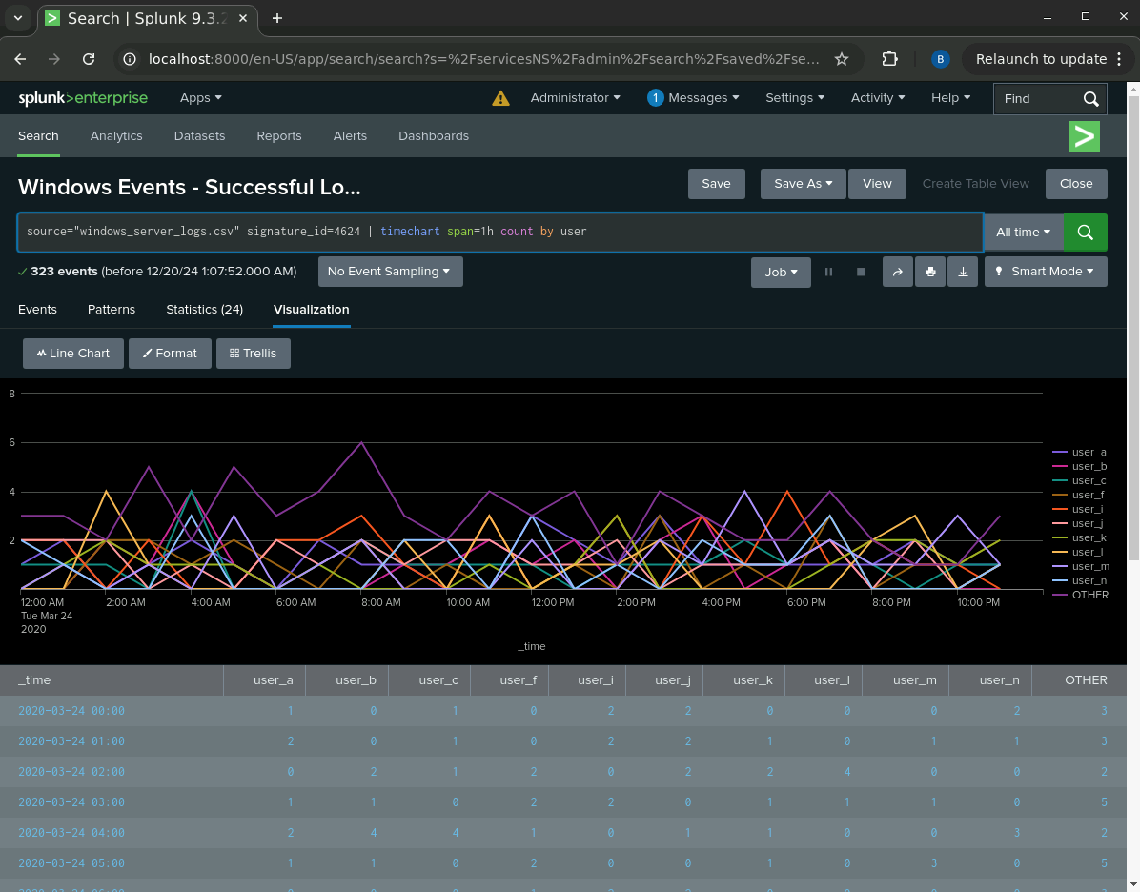

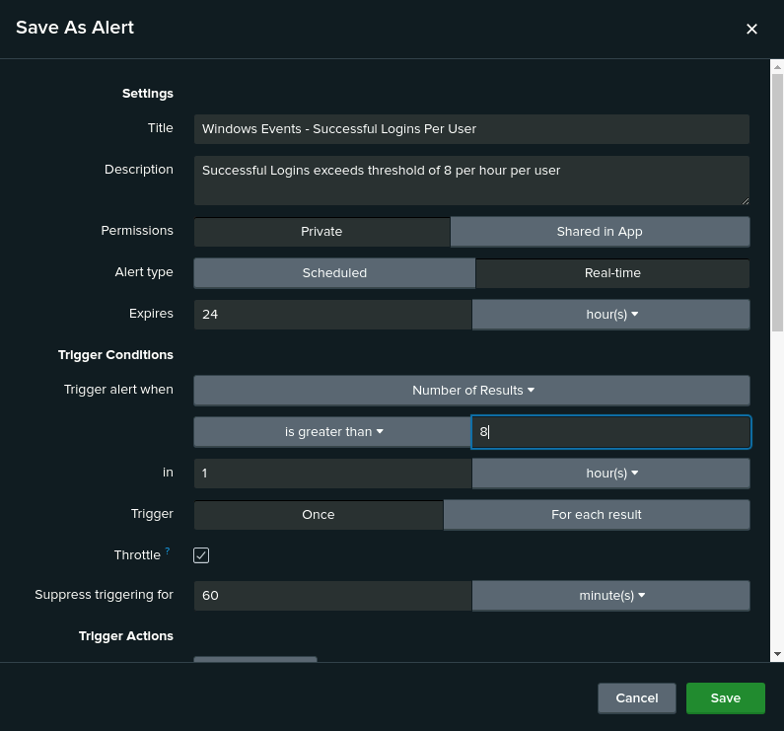

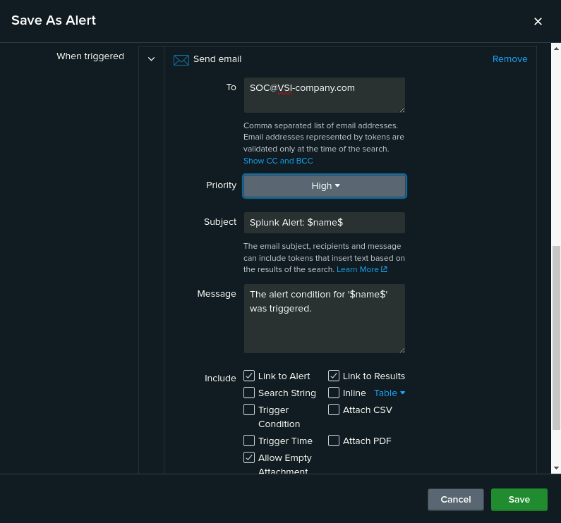

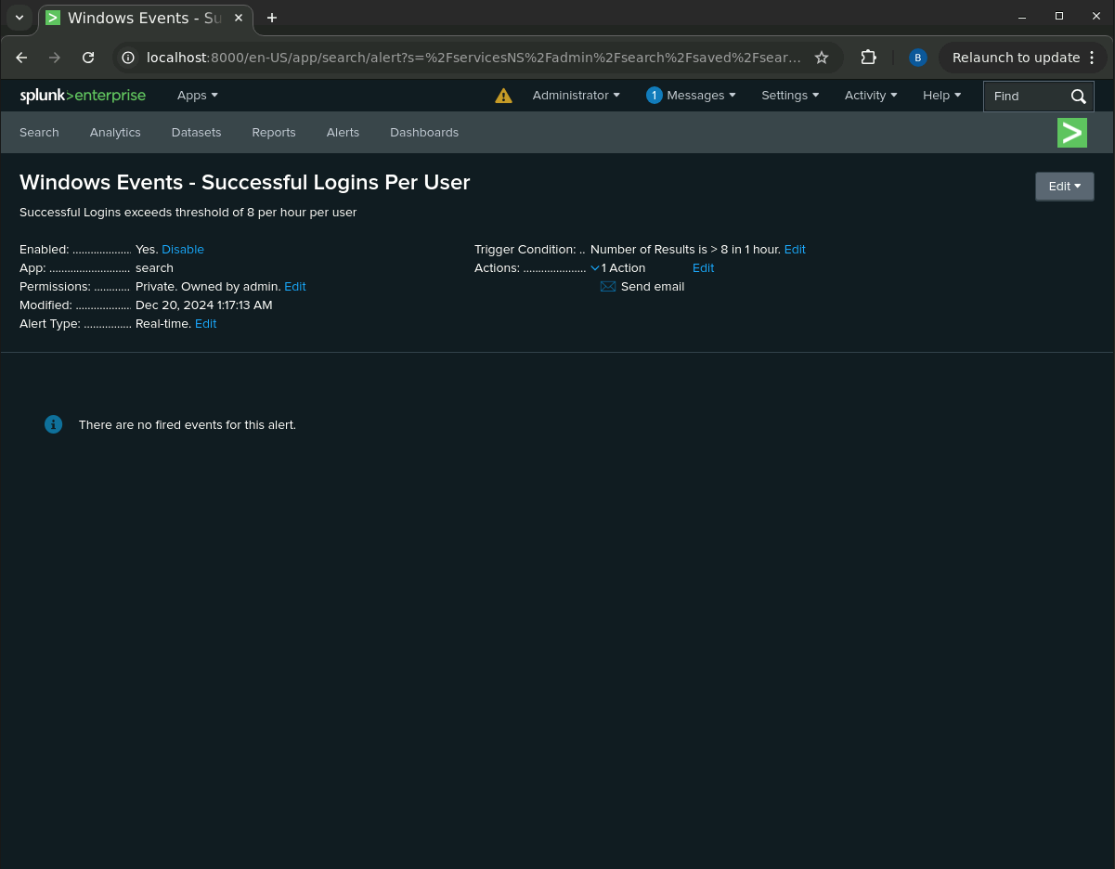

Baseline and threshold for the hourly level of failed Windows activity: Average = 6 failures per hour, Maximum = 10 failures per hour, Recommended Threshold = 12 failures per hour

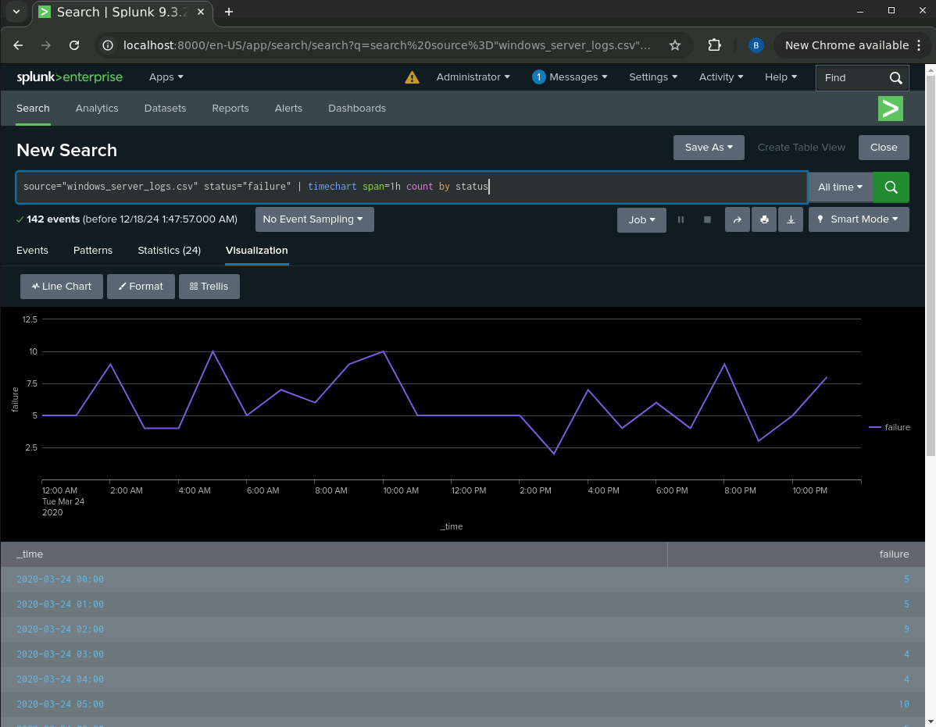

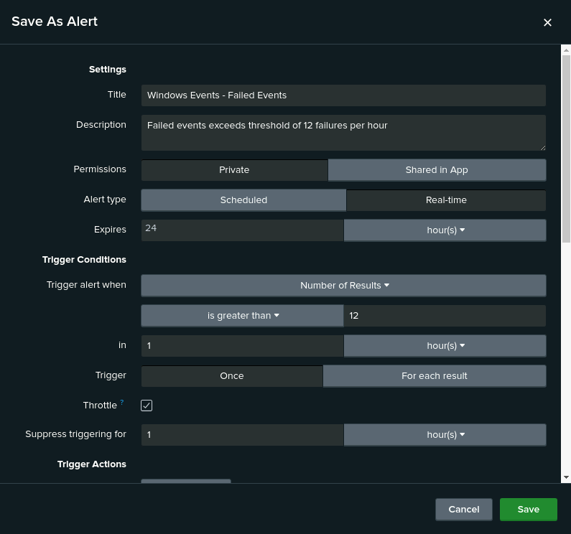

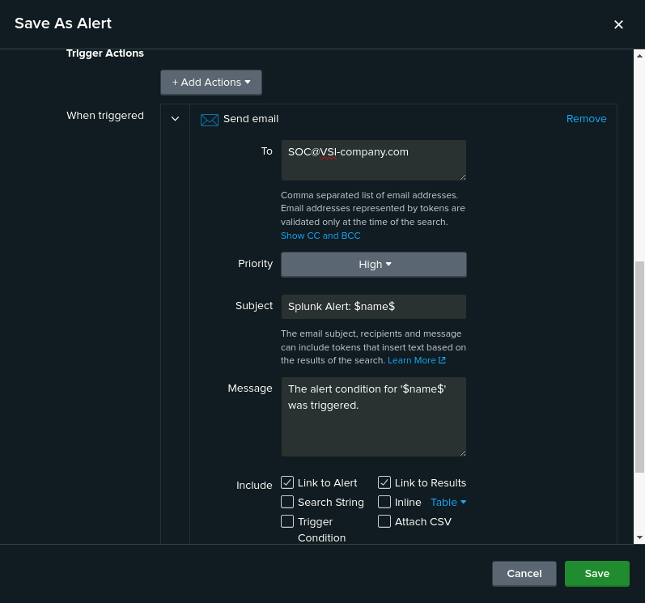

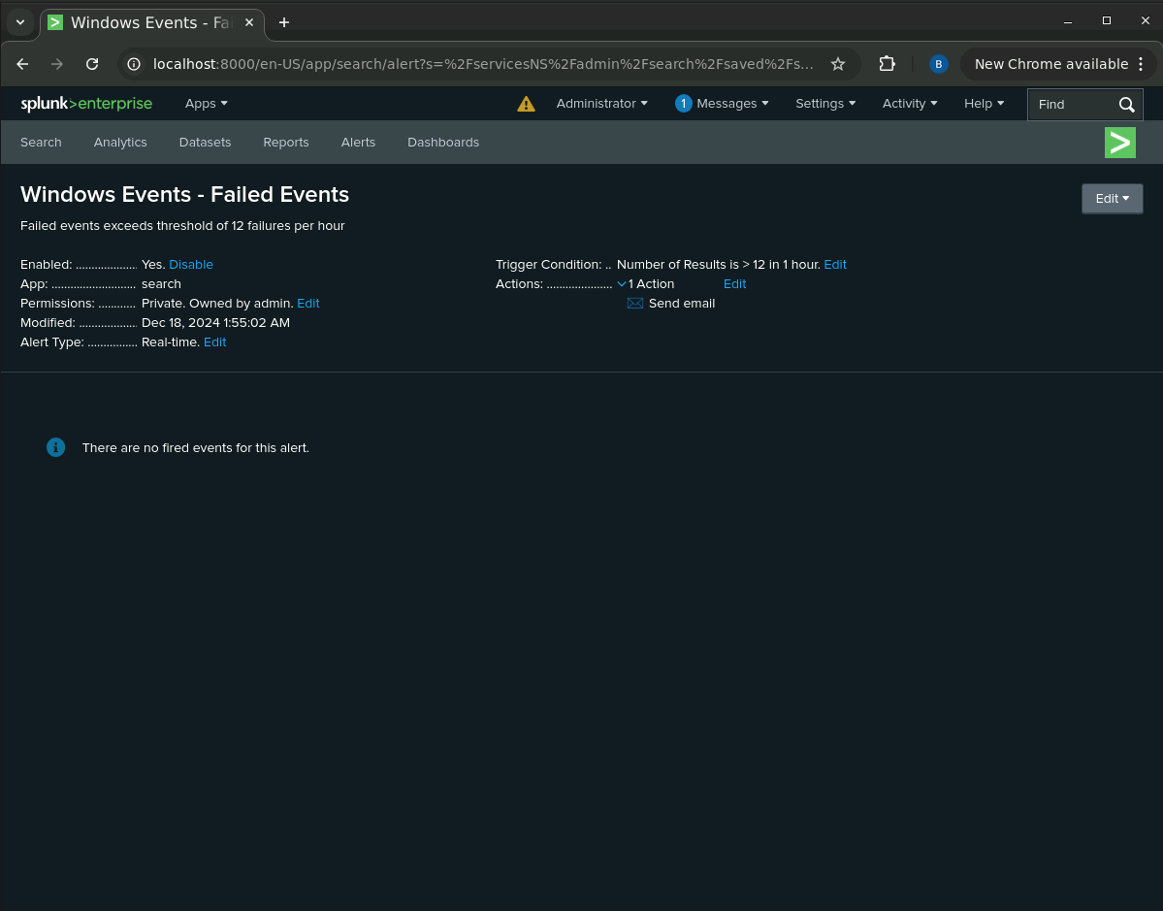

On your dashboard, add the ability to change the time range for all visualizations.

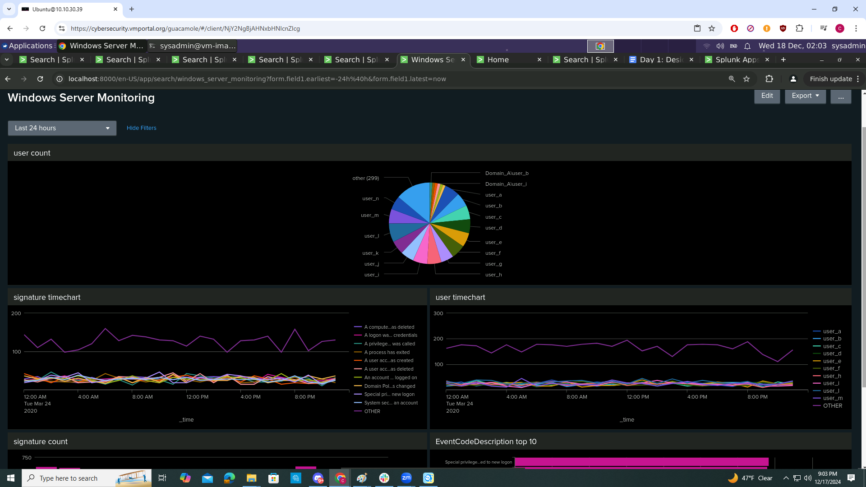

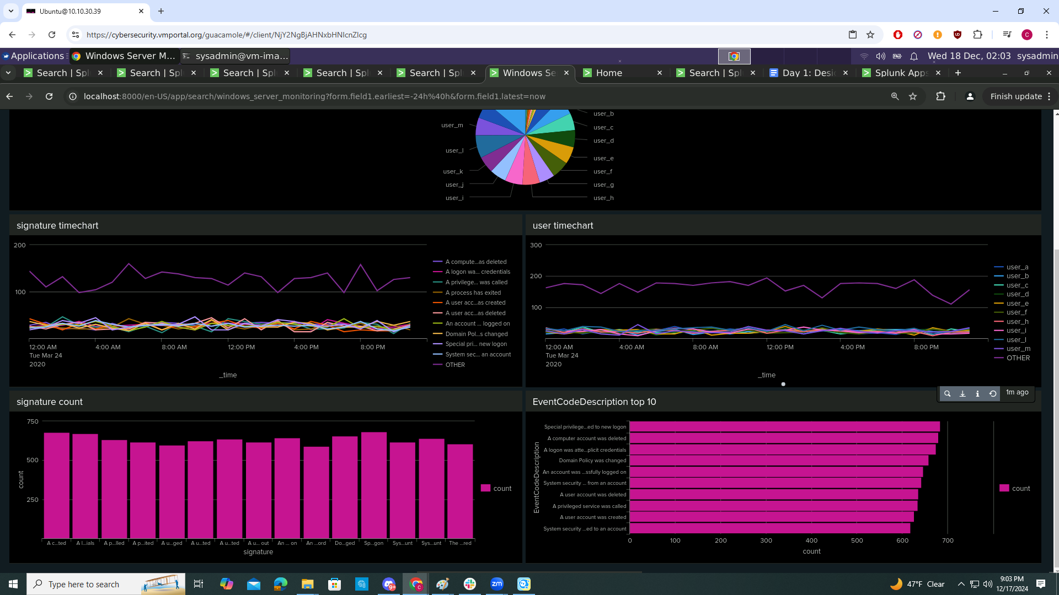

Any single-value visualization of your choice that analyzes any single data

source="windows_server_logs.csv" |top limit=10 EventCodeDescription

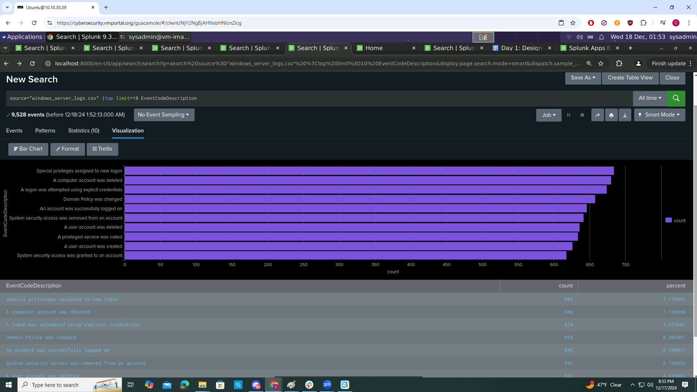

Any visualization that illustrates the count of different users

source="windows_server_logs.csv" | stats count by user

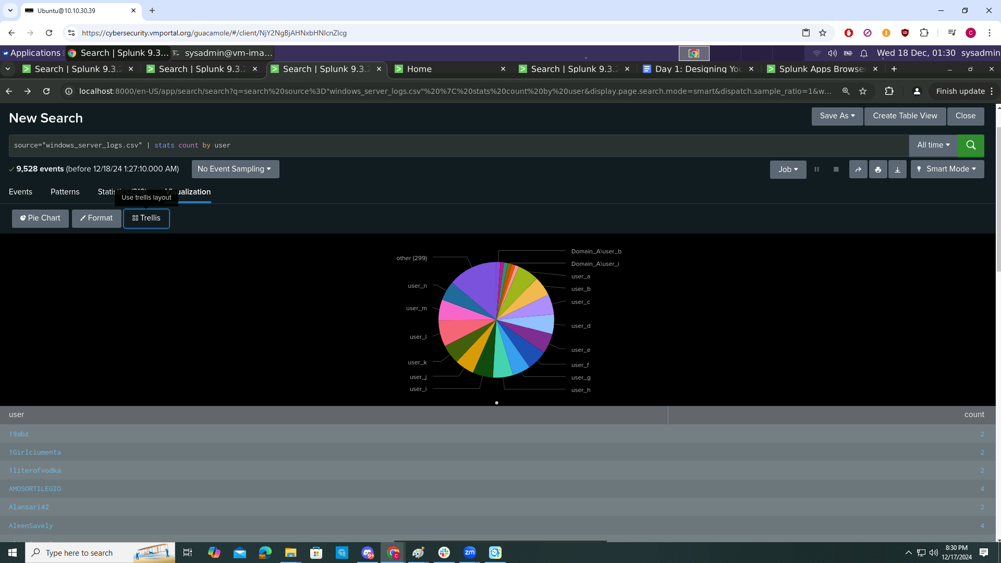

Any visualization that illustrates the count of different signatures

source="windows_server_logs.csv"| stats count by signature

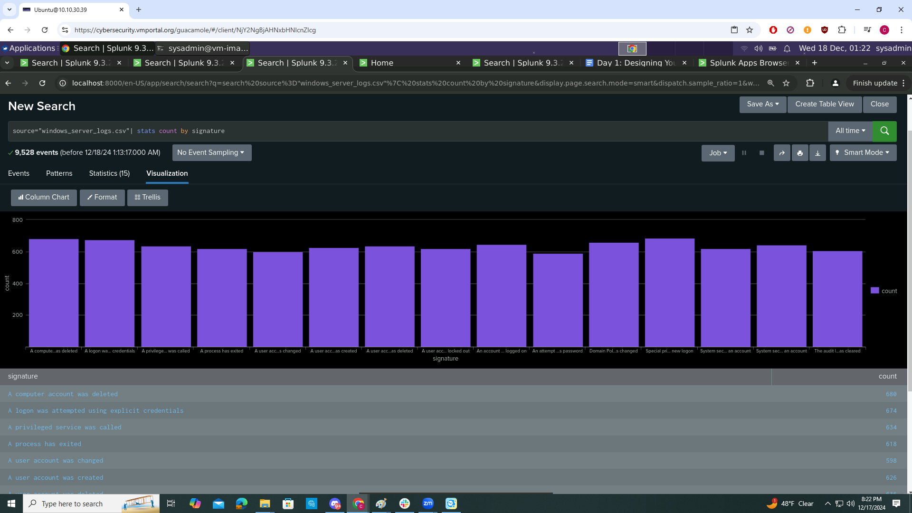

Visualizations and dashboards

A line chart that displays the different “signature” field values over time.

source="windows_server_logs.csv"| timechart span=1h count by signature

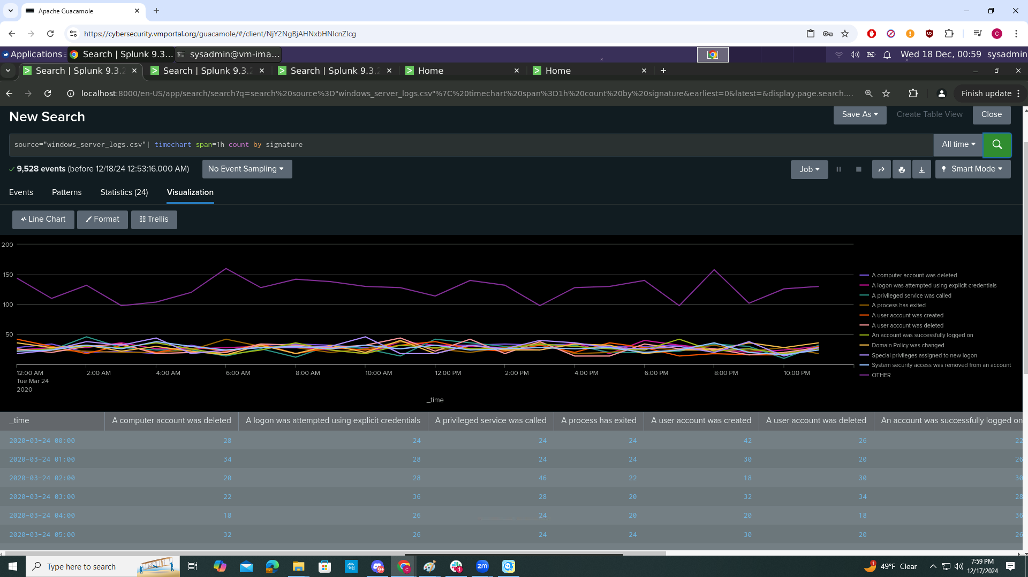

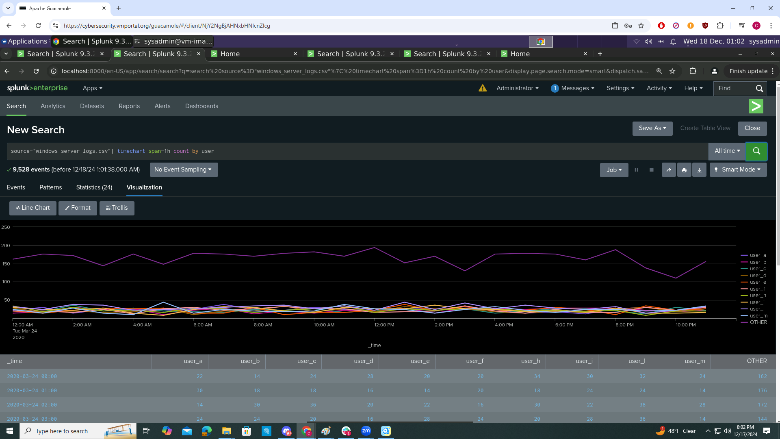

A report with a table of signatures and associated signature IDs: